What "Cool" Used to Look Like - Early Paul Newman
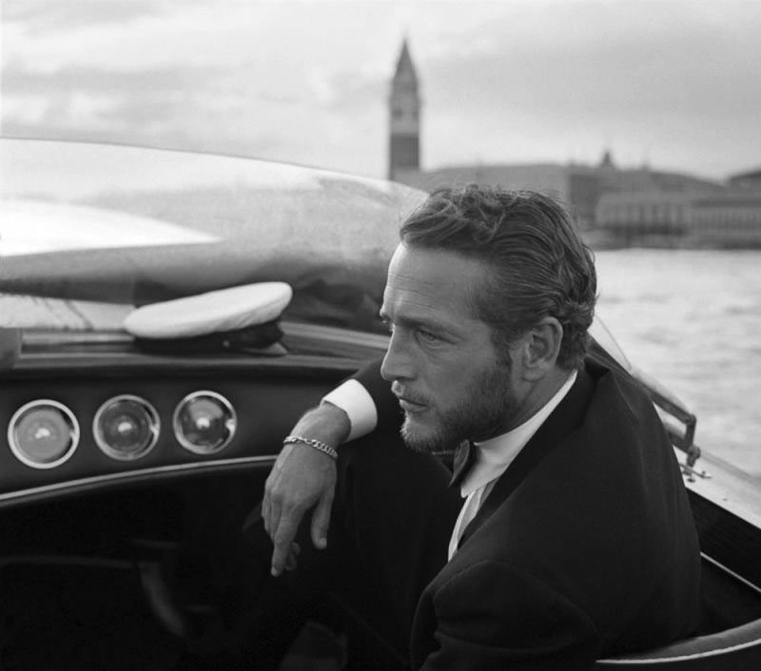

Marlon Brando's screen test in "Rebel without A Cause" (1955).

Children of Chicago (1941)
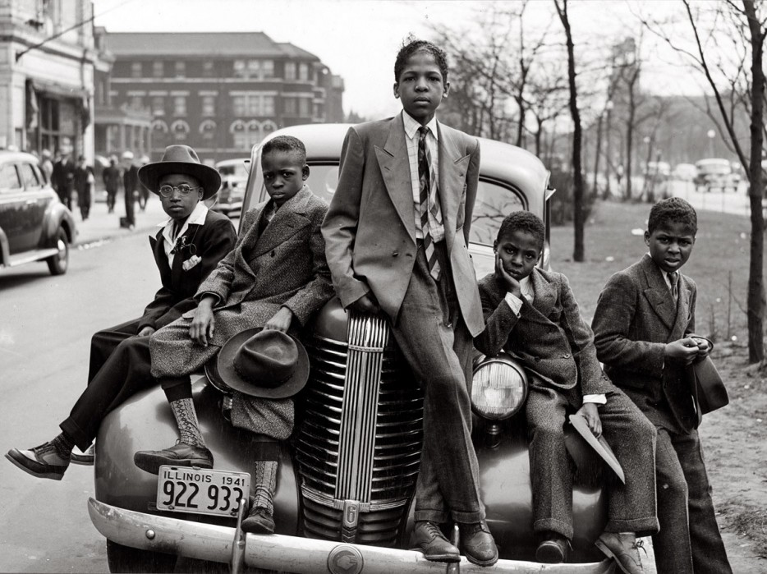

The gorgeous necklines of the 1950s
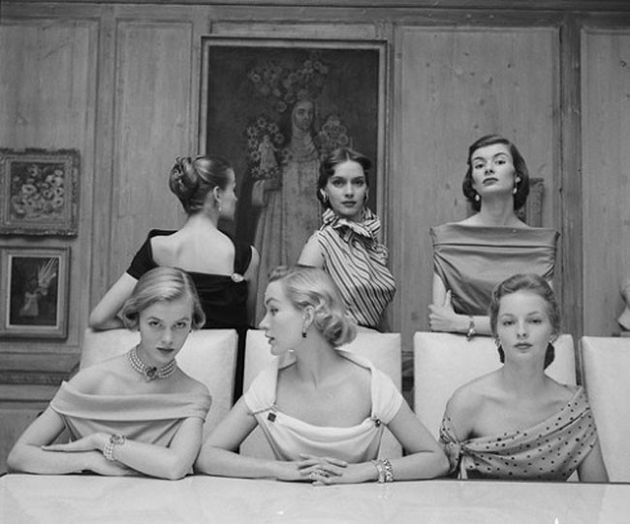

Audrey Hepburn at a premiere on September 14, 1953.
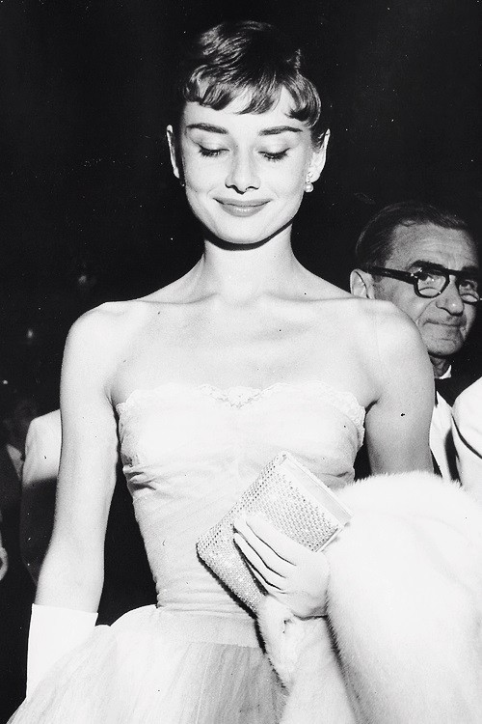
Sigourney Weaver in a suit 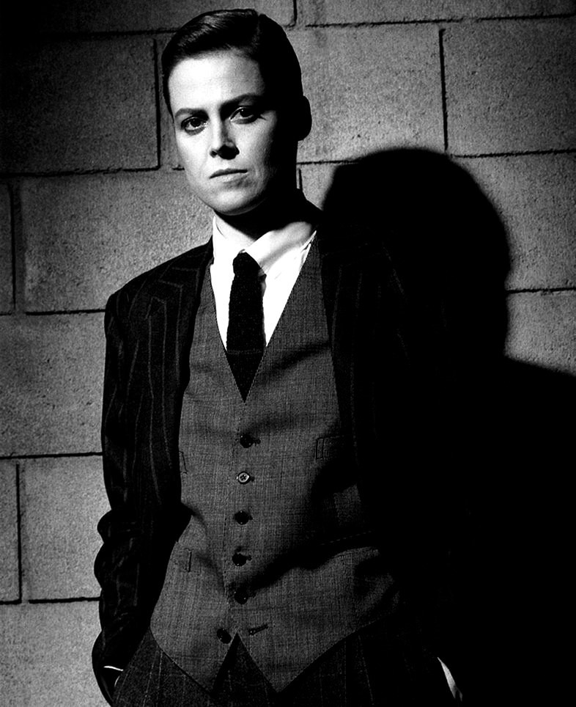
A young Harrison Ford
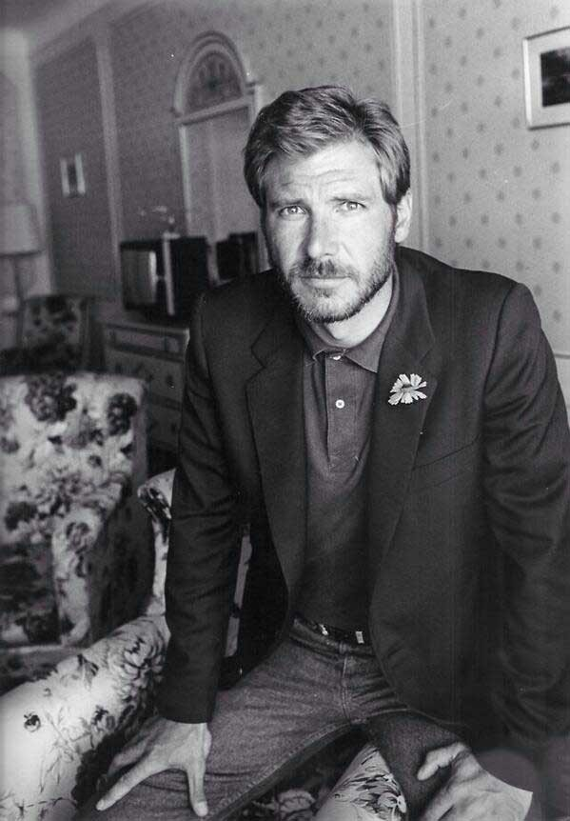

A young boy stealing the show, back when middle school kids knew how to dance (1950)
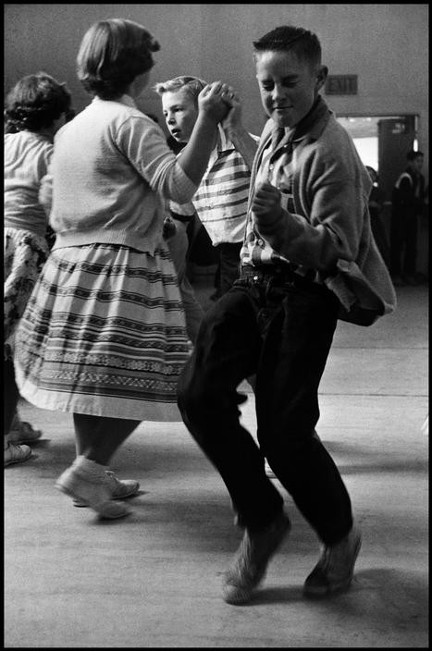
Clint Eastwood with actresses Olive Sturgess and Dani Crayne in San Francisco, 1954
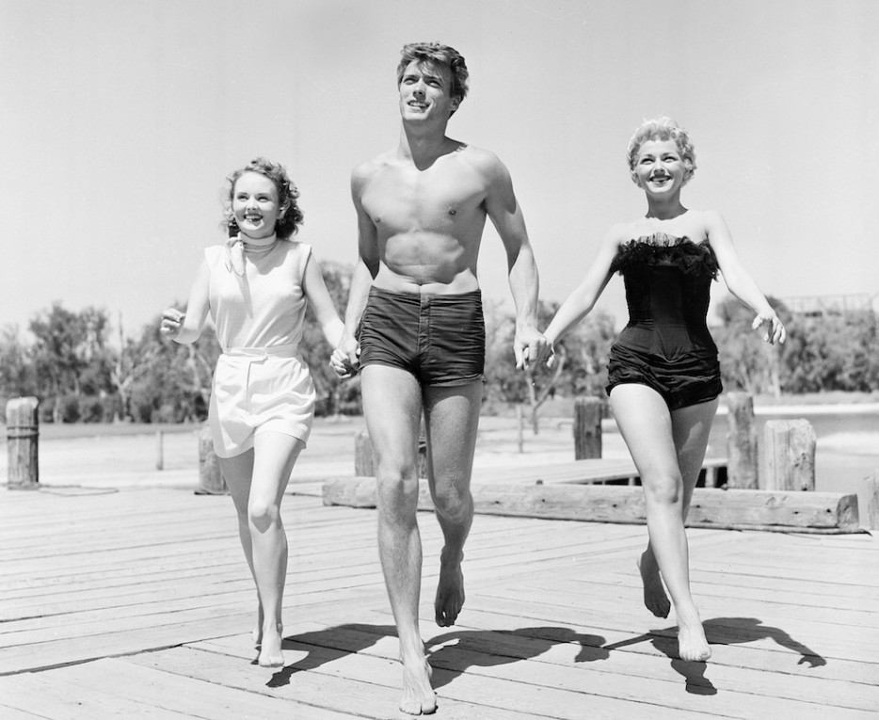

The original way to 'text' in Class (1944)
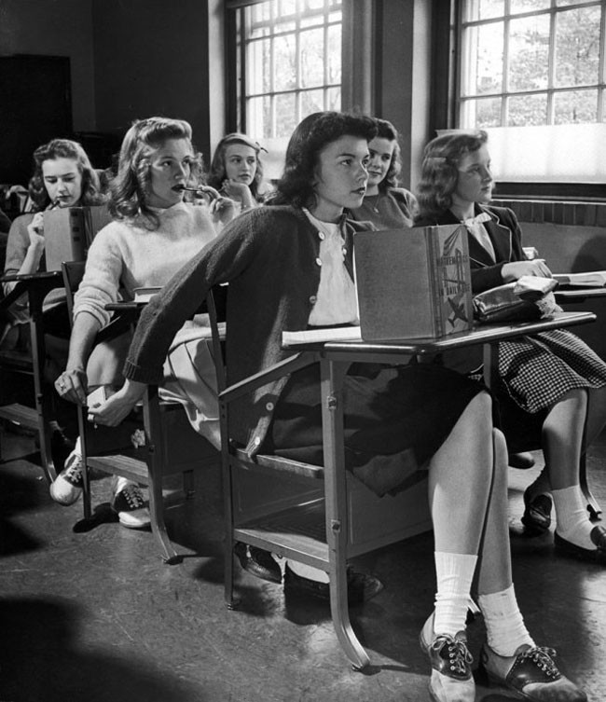
A gang of greasers in NYC, 1950
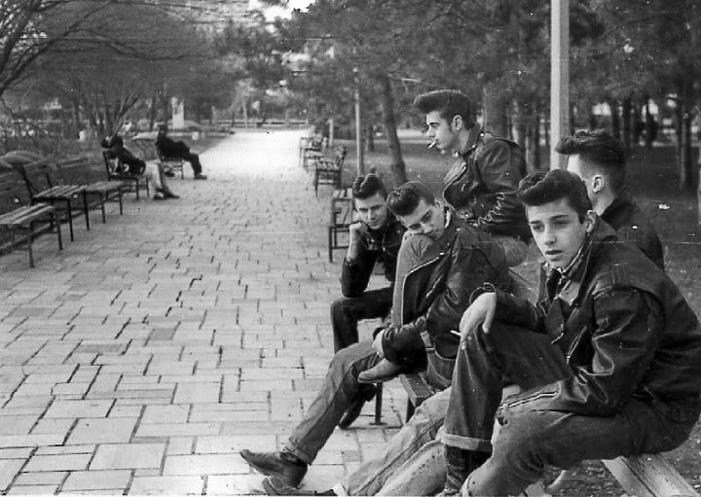

Caroline Kennedy walks ahead while her father, the most powerful man in the world, carries her doll. (1960)
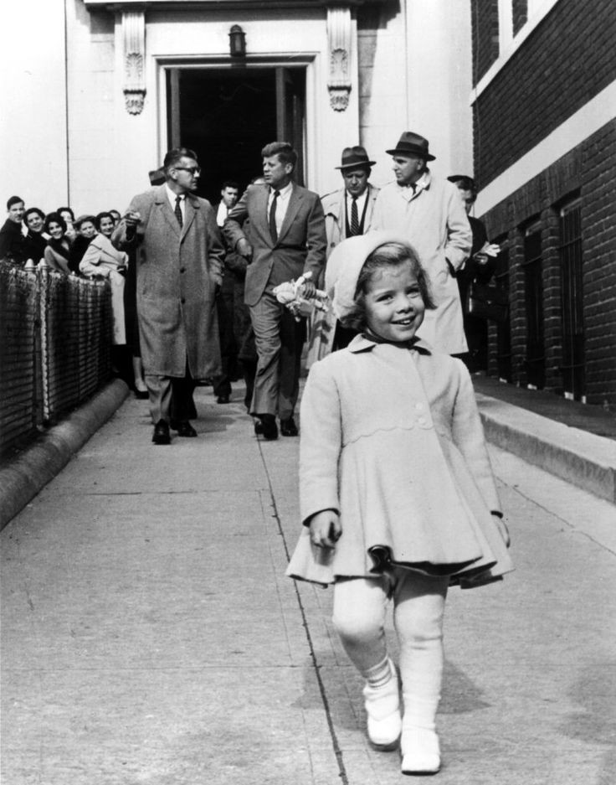

Teenagers and their first car (1950s)
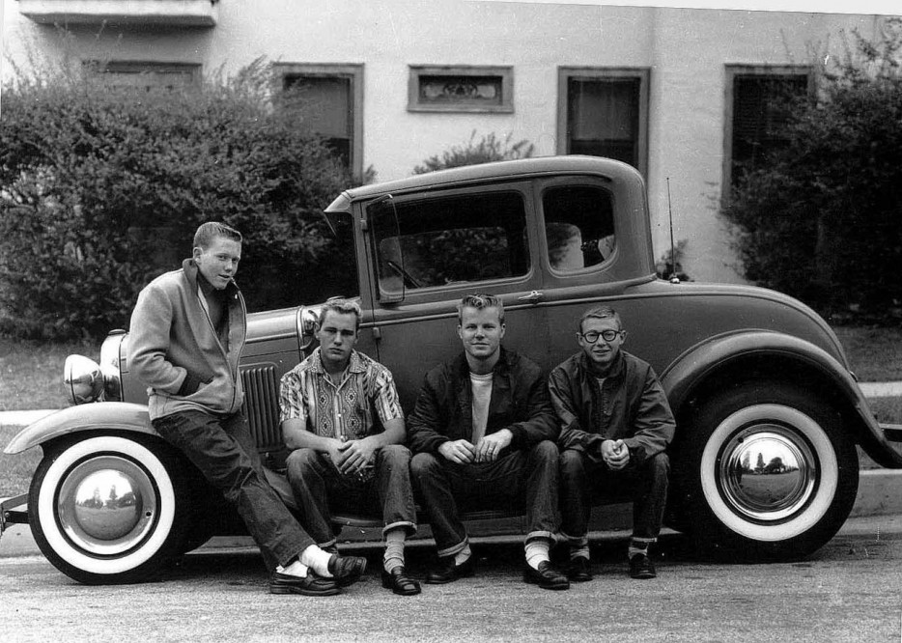

Canadian Prime Minister Pierre Trudeau and his cabinet - 1968. These men knew how to wear a suit.
Pierre Trudeau and his cabinet - 1968. These men knew how to wear a suit.
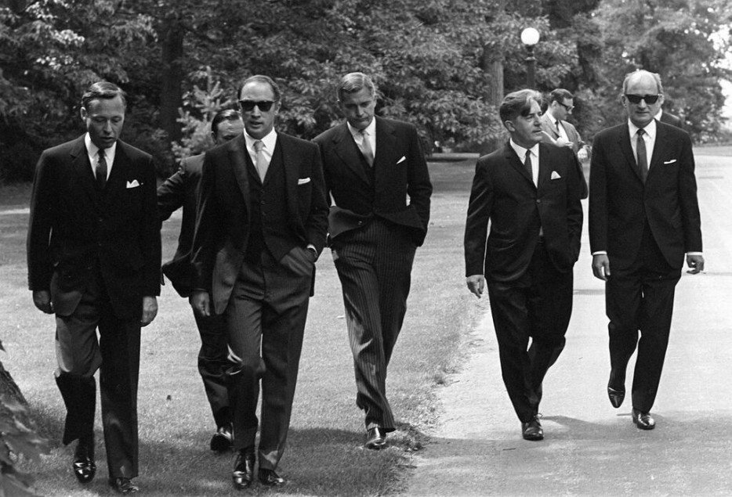

Sophia Loren, one of the actresses to win an Oscar, Grammy, and Golden Globe awards.
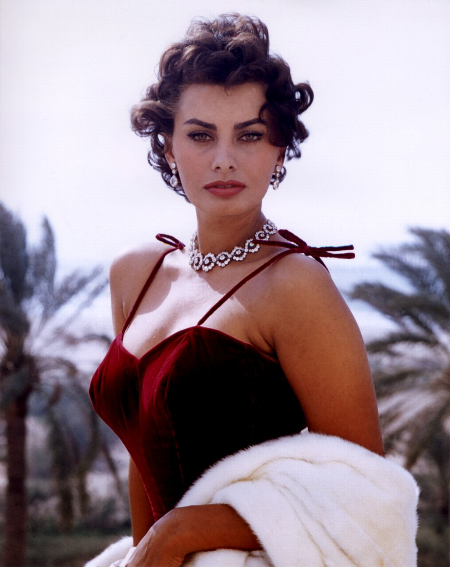
A famous quote of hers: "Sex appeal is fifty percent what you've got and fifty percent what people think you've got."
Ellen O'Neal, the greatest woman free style skate boarder in the 1970s.
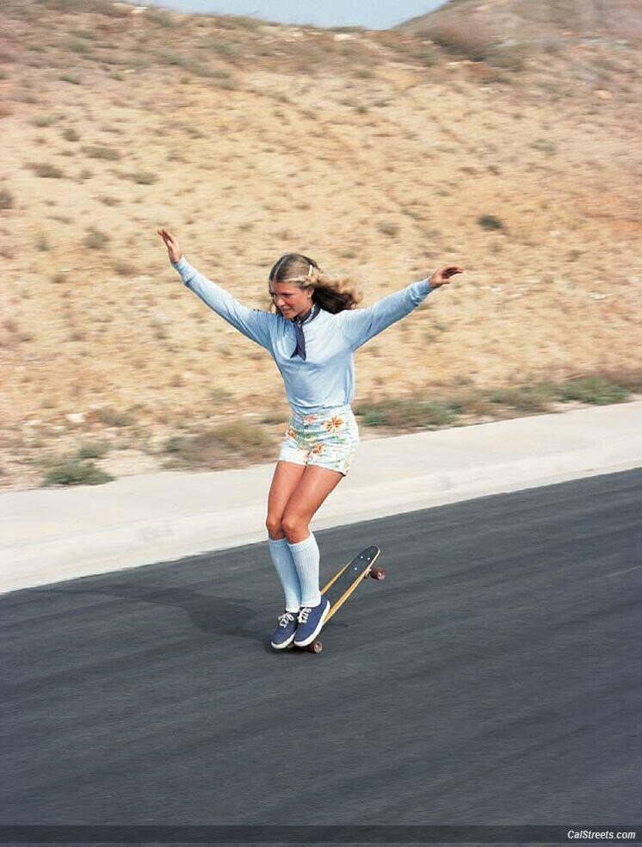
A man ice skating in a suit (1937)
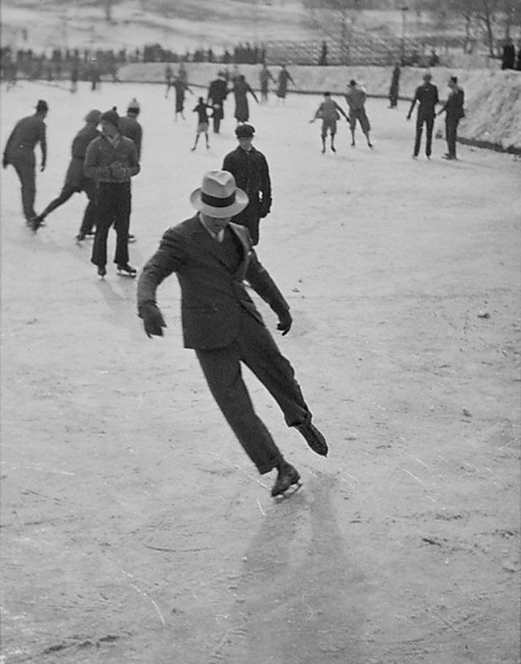
This is how teenagers dated in the 1950s
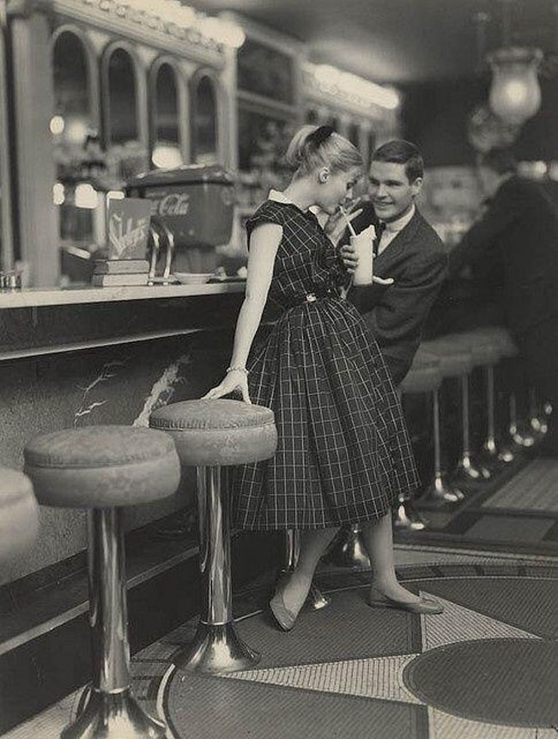
High school fashion feature in Life Magazine (1969)
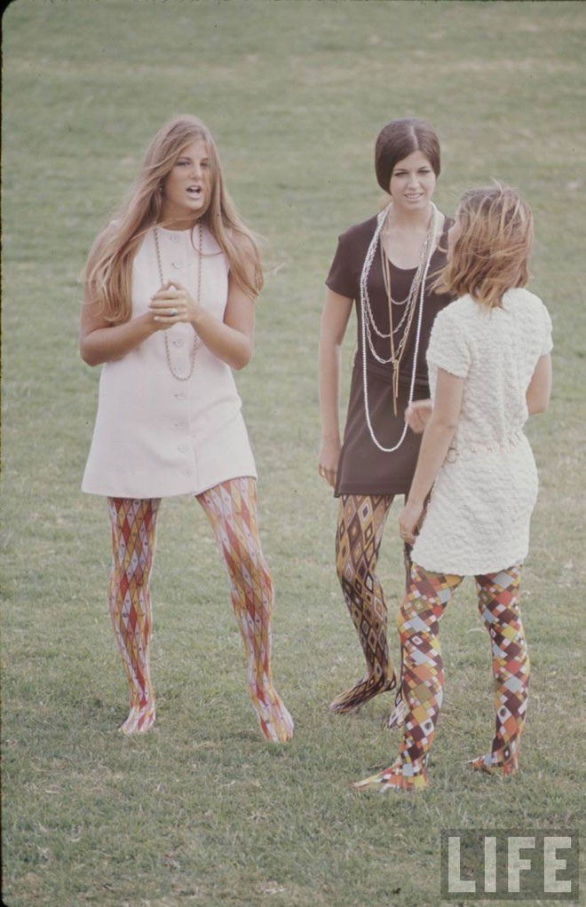
Frank Sinatra stepping out of a helicopter with a drink
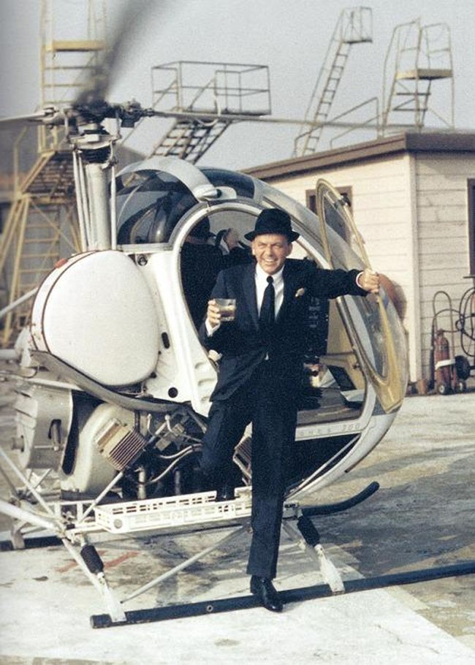
Dean Martin & Angie Dickinson on the set of Rio Bravo, 1959
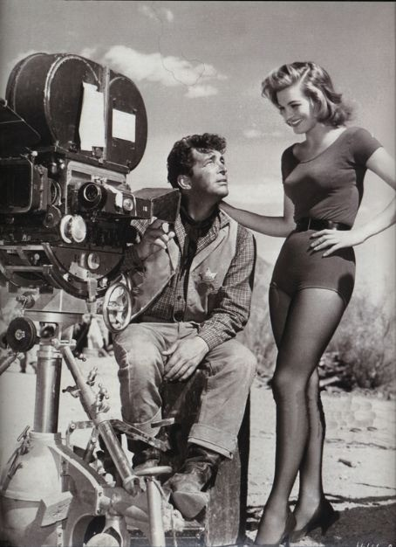
Girl with typewriter and a smoke
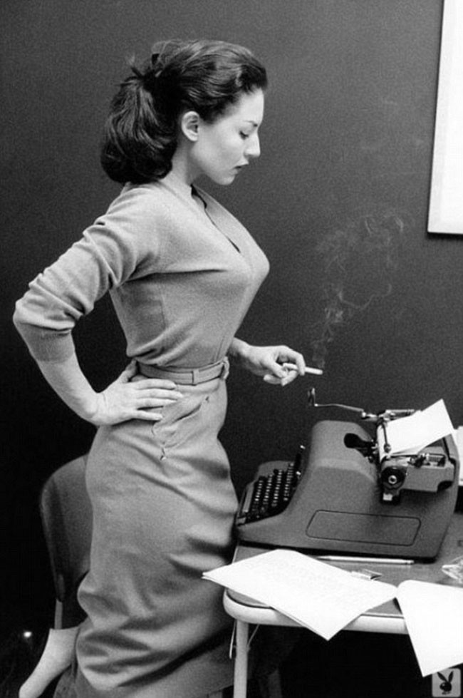
A couple on Michigan Avenue in Chicago (1975)
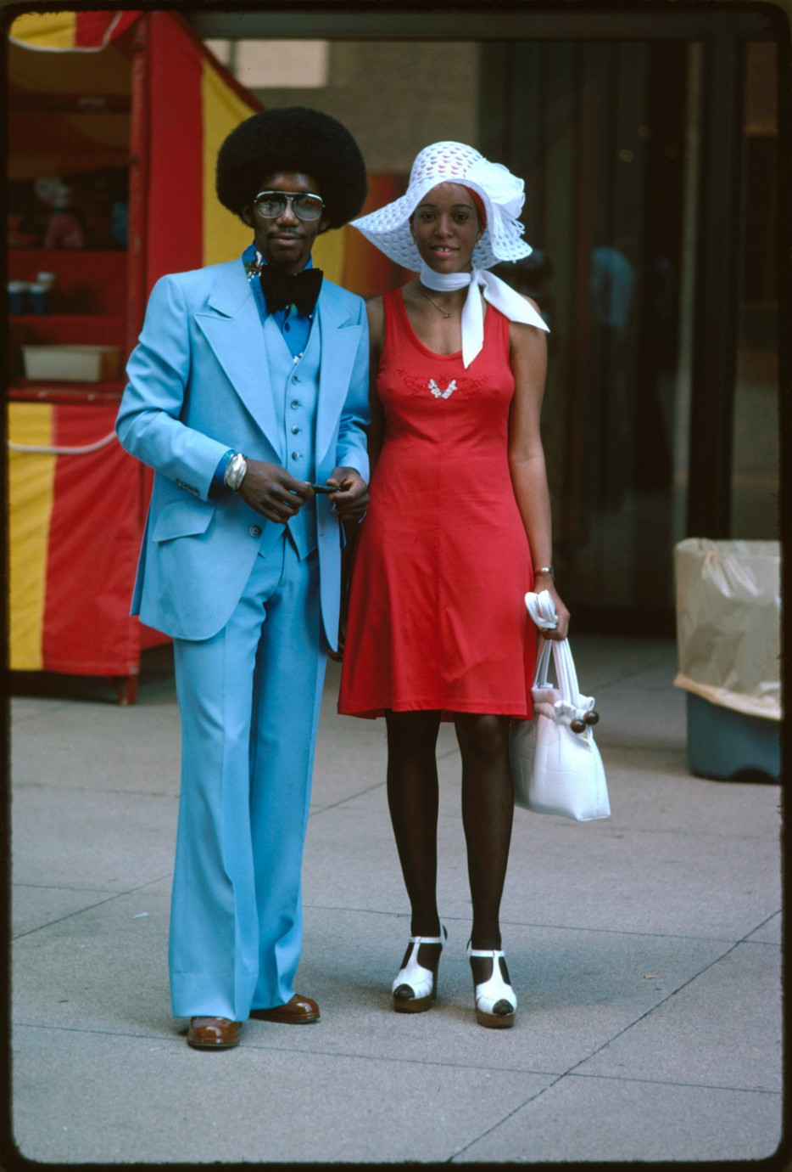
A stylish couple in the rain in London (1963)
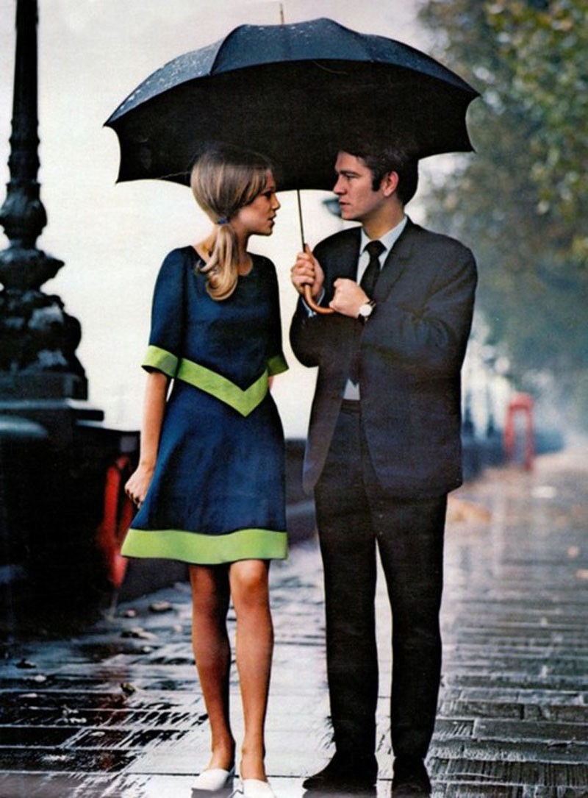Queen Elizabeth and Prince Phillip at the horse races (1968)
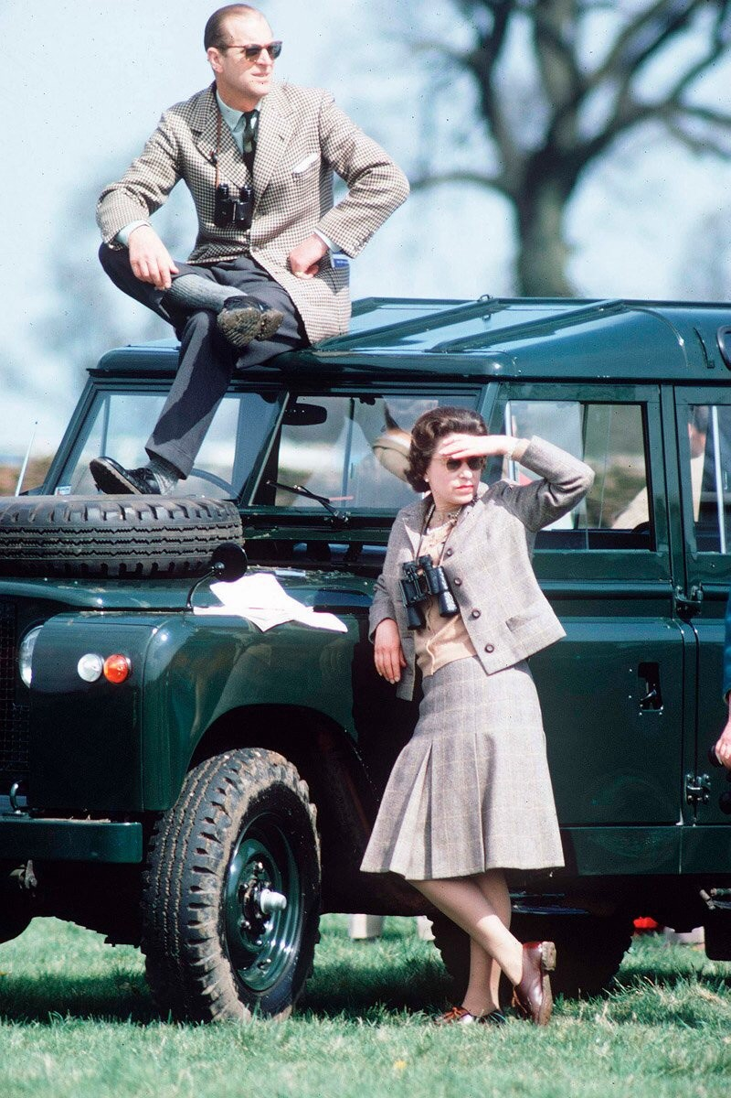
Muhammad Ali looking dapper
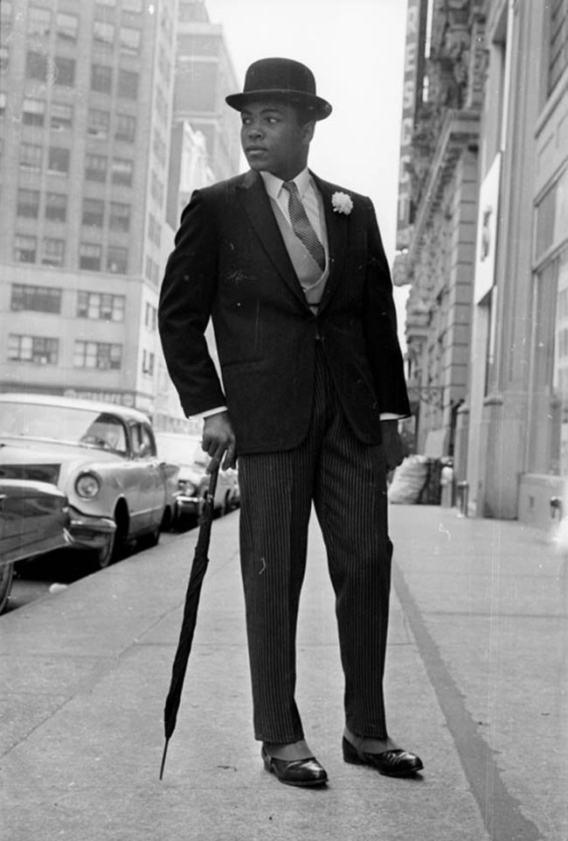
Paul McCartney and Mick Jagger sit opposite each other on a train to Bangor. (1967)
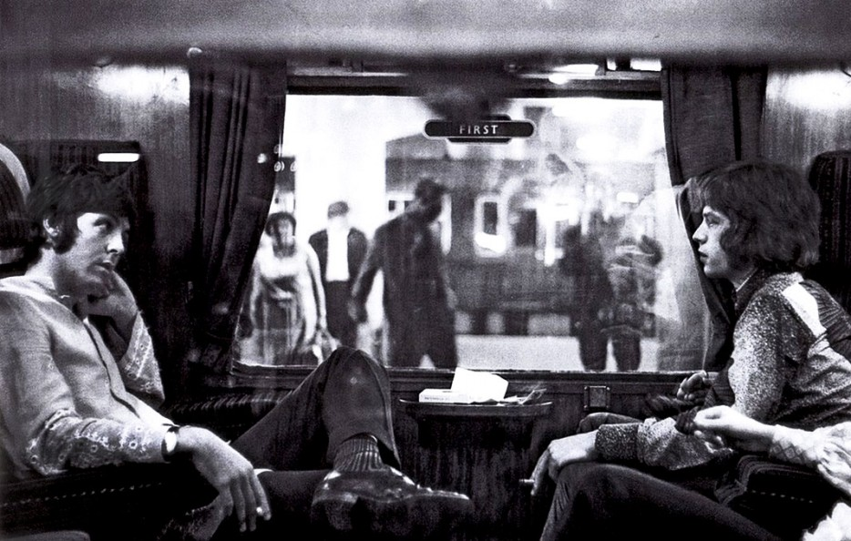

A salesman has his motorized roller skates refueled at a gas station (1961)
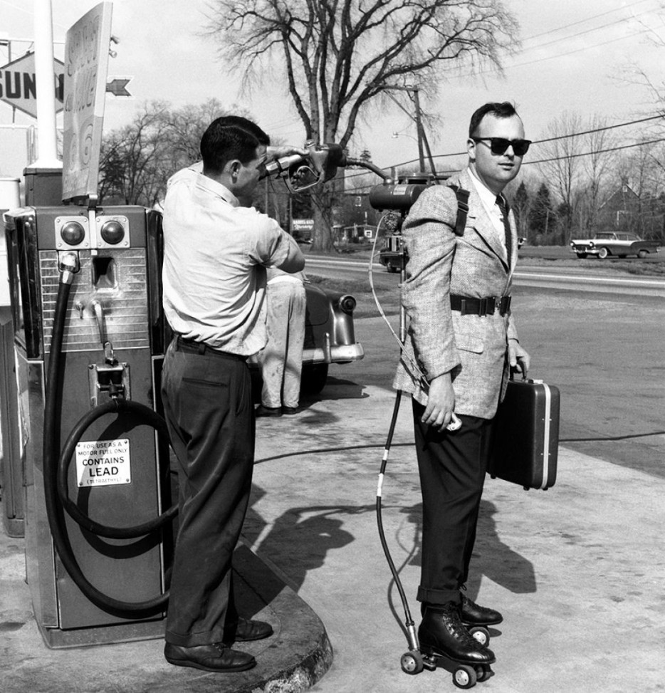

A young Michael Caine in 1959
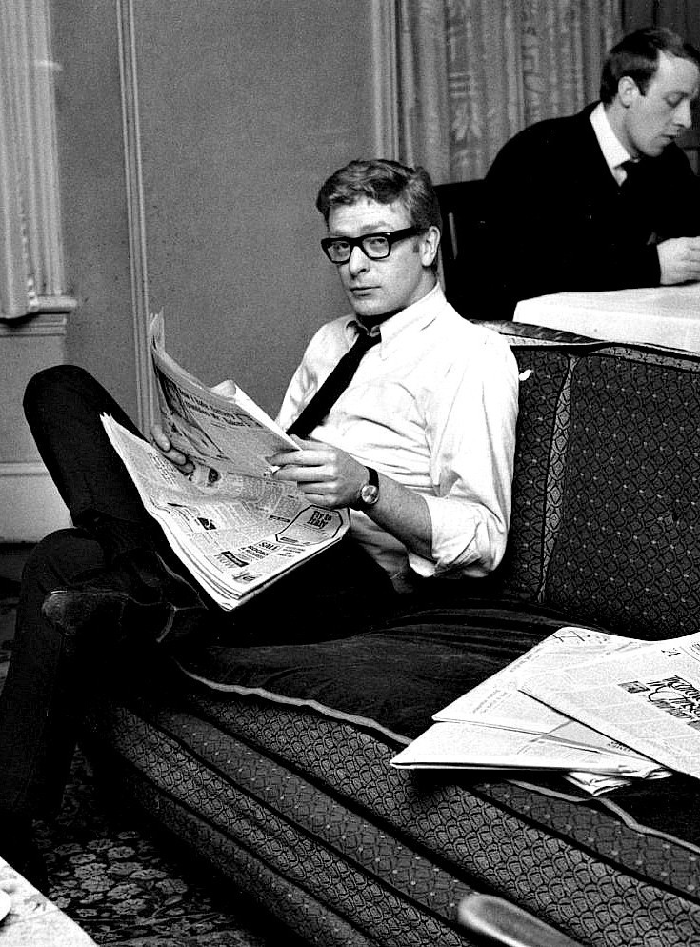
A couple dancing in a 1950's "Be Bop" theater as everyone looks on.
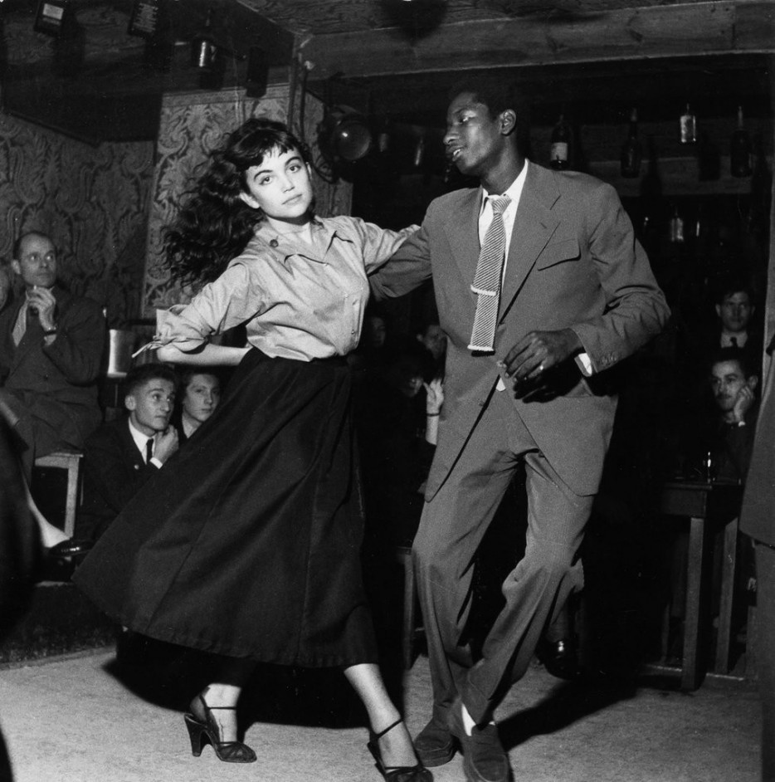

Girl on a scooter (1969)
Ernest Hemingway's striking passport photo (1923)
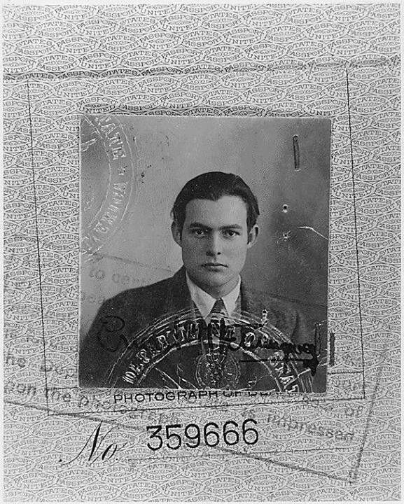

The definition of old school cool. Cary Grant in the 1950s
