**And the years go by.....**Cinderella is divorced…

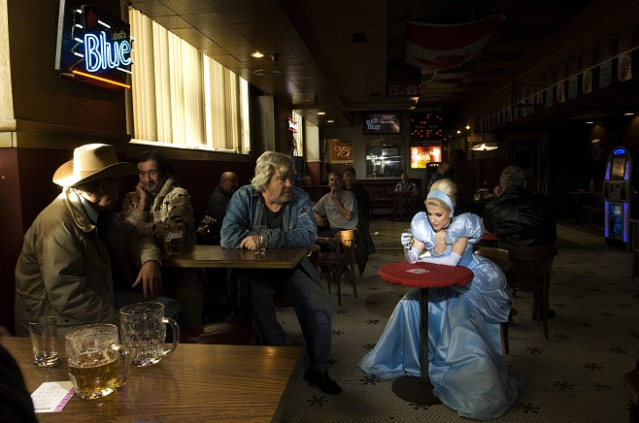

Snow-white has not been so lucky…

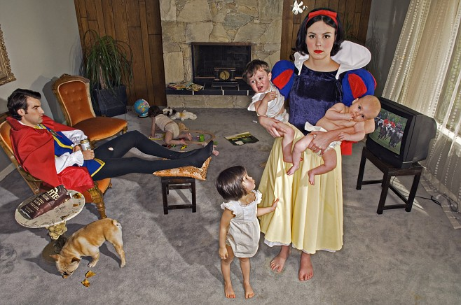

Little-Red-Riding-Hood hasn’t seen the Wolf since…

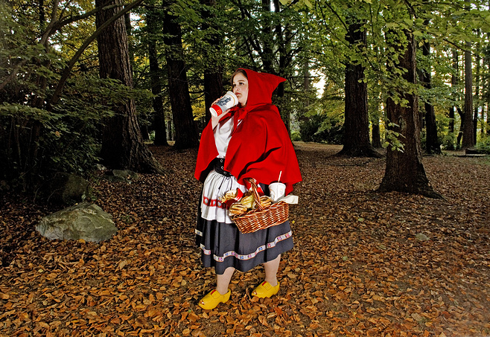

Sleeping Beauty is still asleep…

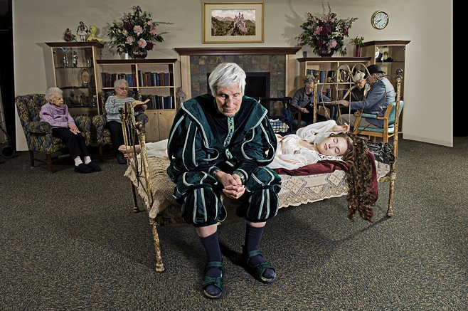

The Little Mermaid has met a sad fate



Barbie celebrated her 50th Birthday this year…

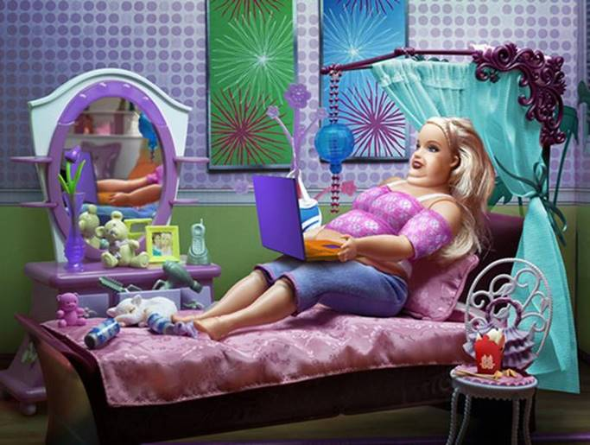

Little Tweety is 60 years old…

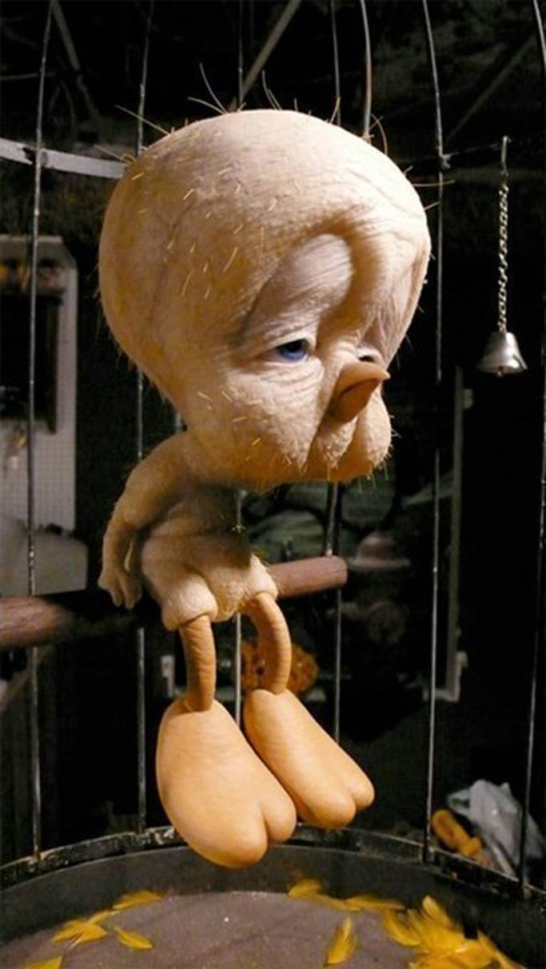

 So is Superman…  
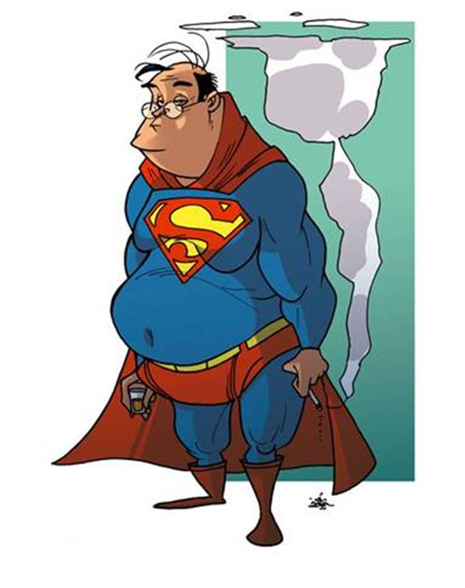

Wonder Woman is menopausal…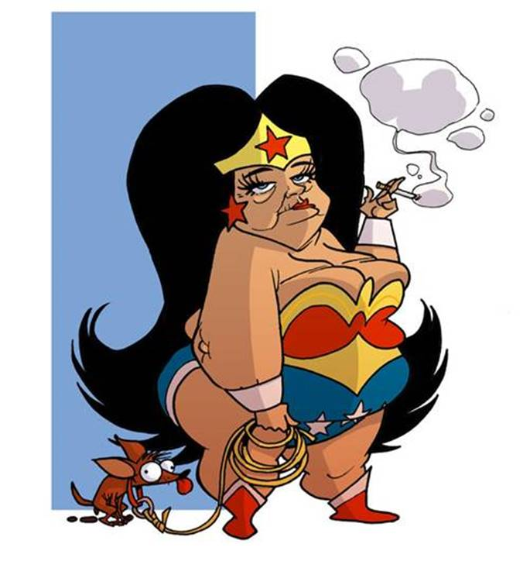

Batman and Robin are living it up at the Nursing Home…  
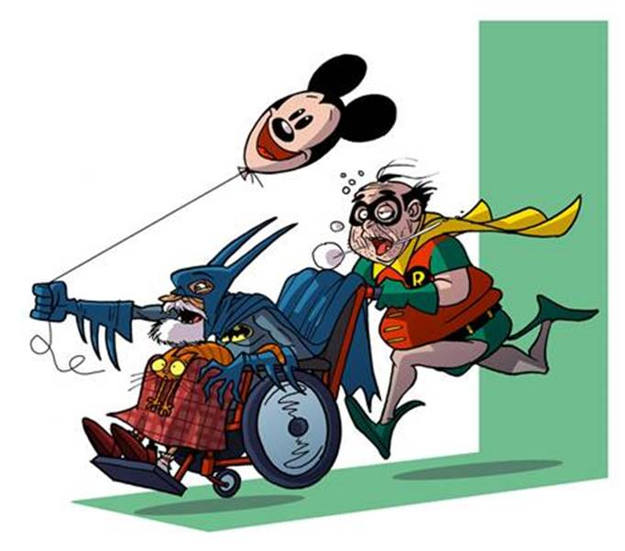

Spider-Man is attached to different threads…

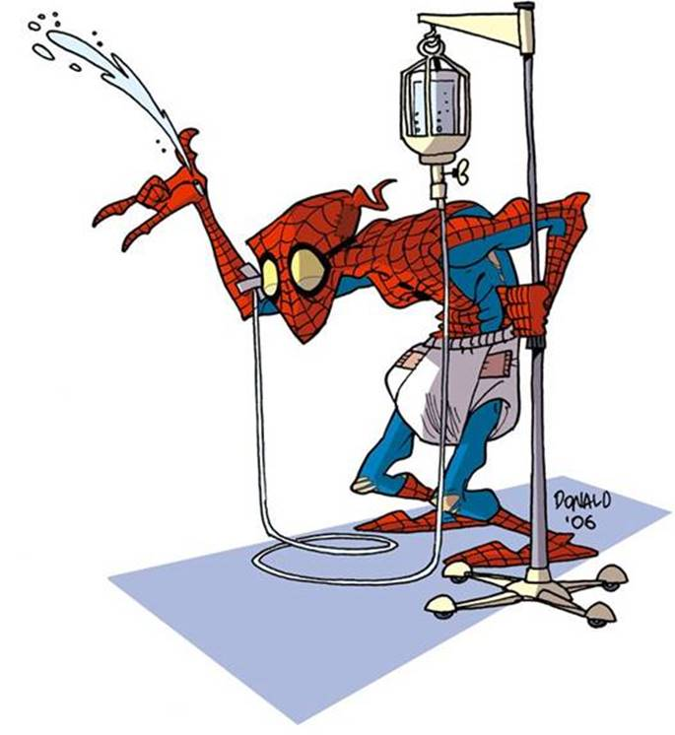

[**Life is short… So Smile !**](https://urldefense.proofpoint.com/v1/url?u=http://www.google.com.au/url?sa%3Di%26rct%3Dj%26q%3D%26esrc%3Ds%26source%3Dimages%26cd%3D%26cad%3Drja%26docid%3DbhDNApeBB2ky-M%26tbnid%3DRThGoIv4IJWp9M:%26ved%3D0CAUQjRw%26url%3Dhttp://www.iconshock.com/icons/sophistique/communications/smile_wink_b-icon.html%26ei%3DtpPZUp-7I46hlQXoiIGoAg%26bvm%3Dbv.59568121%252cd.dGI%26psig%3DAFQjCNG9_kZjaM7xBpY4133xo_HIl1fgHw%26ust%3D1390077210764042&k=0ydYJQR7GW8D38gQ8zEhJA%3D%3D%0a&r=VR2tp://www.google.com......au/url?sa%3Di%26rct%3Dj%26q%3D%26esrc%3Ds%26source%3Dimages%26cd%3D%26cad%3Drja%26docid%3DbhDNApeBB2ky-M%26tbnid%3DRThGoIv4IJWp9M:%26ved%3D0CAUQjRw%26url%3Dhttp://www.iconshock.com/icons/sophistique/communications/smile_wink_b-icon.html%26ei%3DtpPZUp-7I46hlQXoiIGoAg%26bvm%3Dbv.59568121%252cd.dGI%26psig%3DAFQjCNG9_kZjaM7xBpY4133xo_HIl1fgHw%26ust%3D1390077210764042&k=0ydYJQR7GW8D38gQ8zEhJA%3D%3D%0a&r=VR264rYynw09XNiLy6dmNg%3D%3D%0a&m=J5fwNveky%20%20%20%0d%0aa%20zMpG%0d%0aX%20mNtLRY1Sv8N9IndKJIo1i8s/9ZJ8%3D%0a&s=b3224582e009d2f38bc78278bcf0533686c4cf8cb7b58318bc1d3d79ca7a933a)

**Old age is not for sissies...**