World WCs

**Wherever you travel, be sure you understand this important signage:**

**Restroom signs around the world.**

**People of earth are creative with their bathrooms**

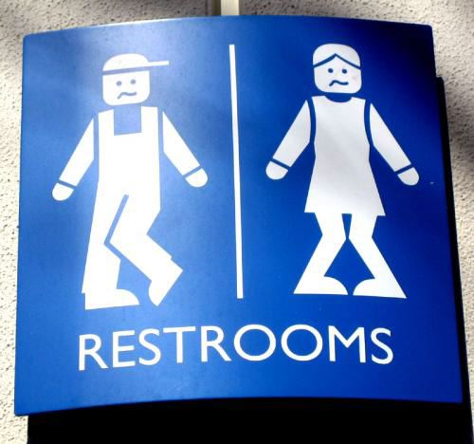

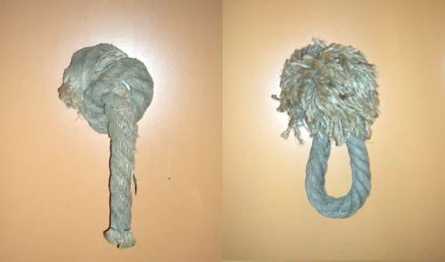

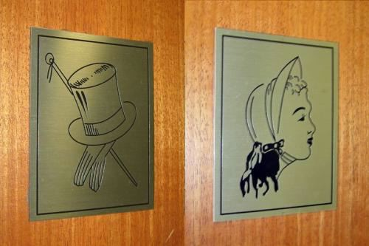**..**

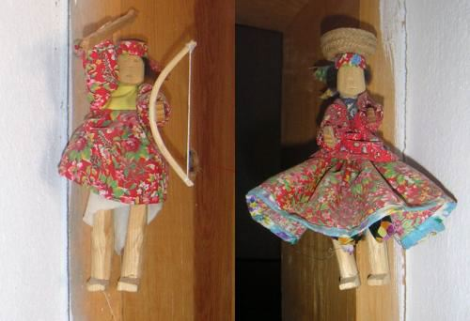

I'M STILLL NOT SURE WHICH ONE??? THEY BOTH HAVE SKIRTS

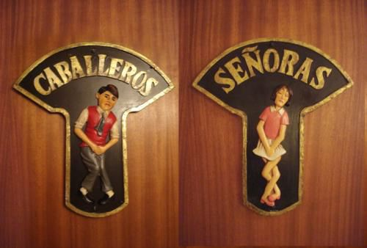

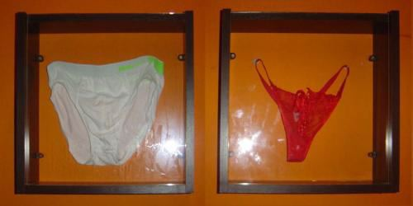

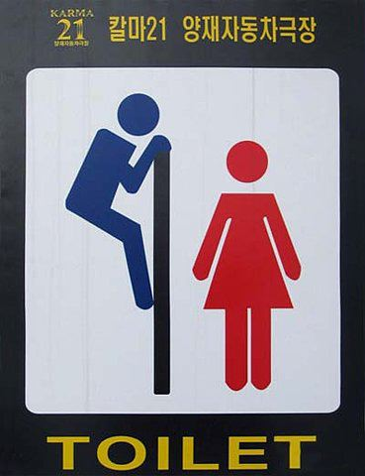

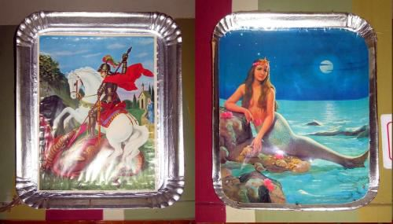

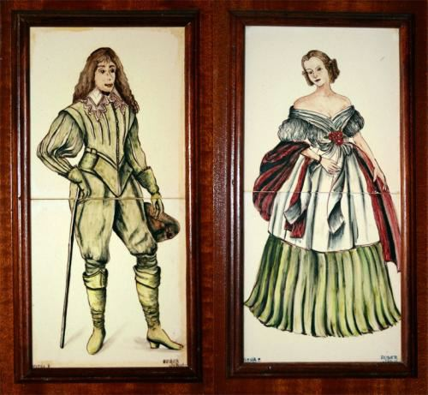

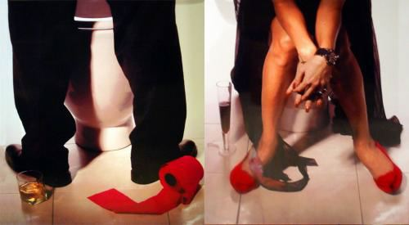

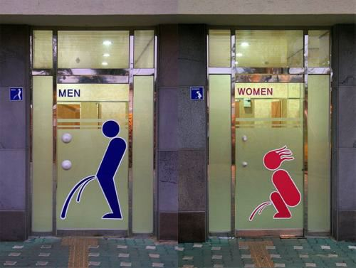

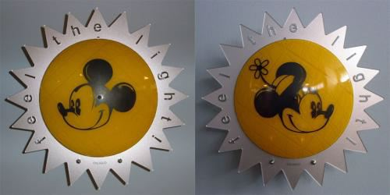

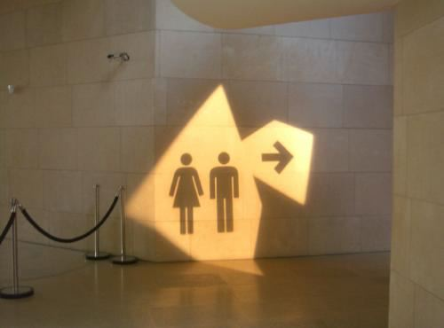

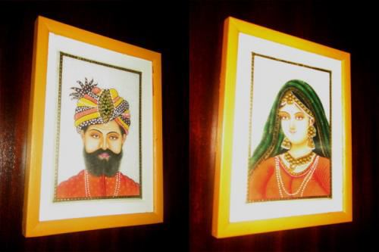

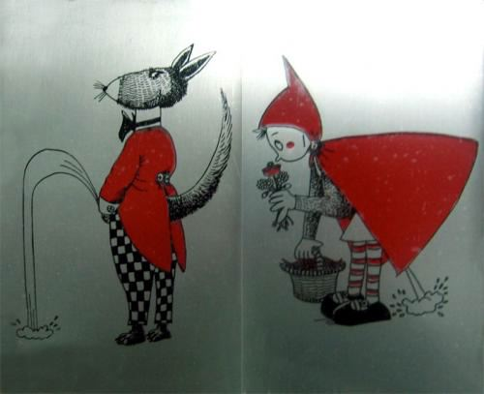

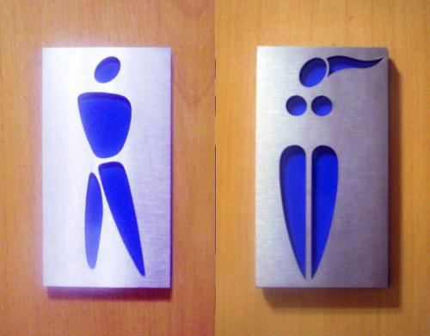

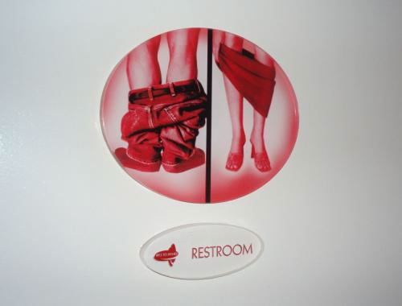

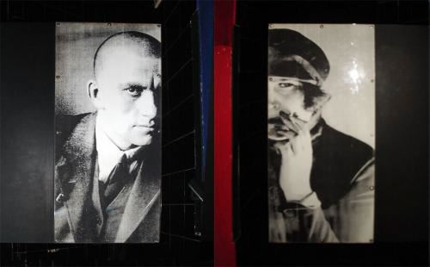

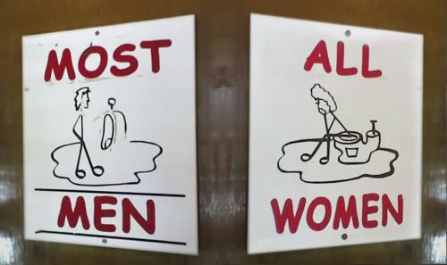

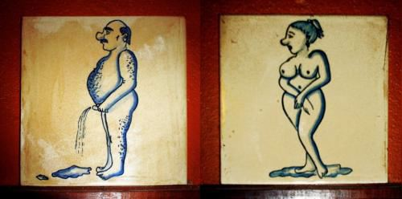

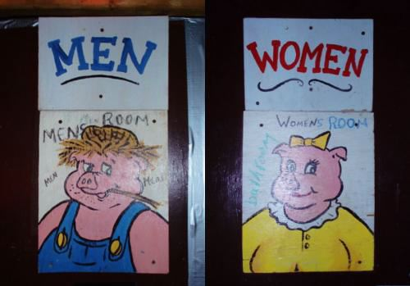

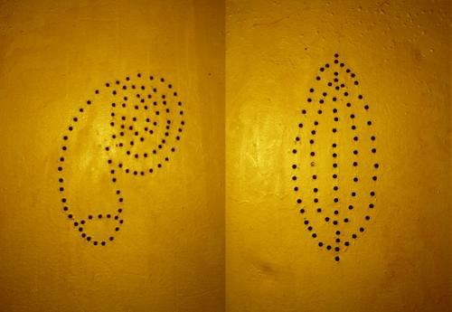

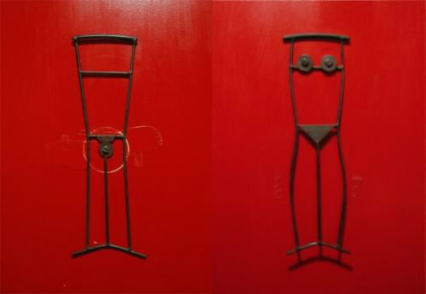

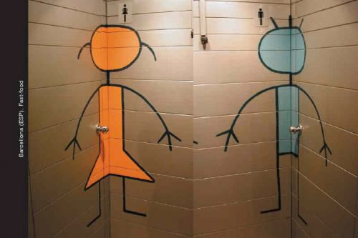

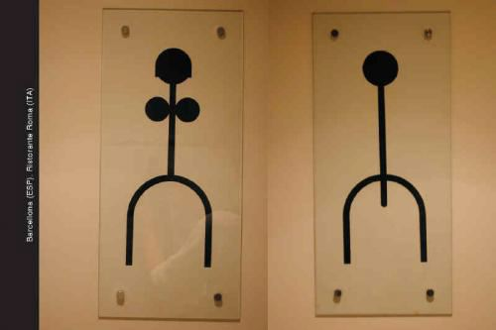



**Awesome Toilet**

THE LADY IS GETTING READY TO ENTER!!  
This is a picture of a public toilet in Houston   
  
  
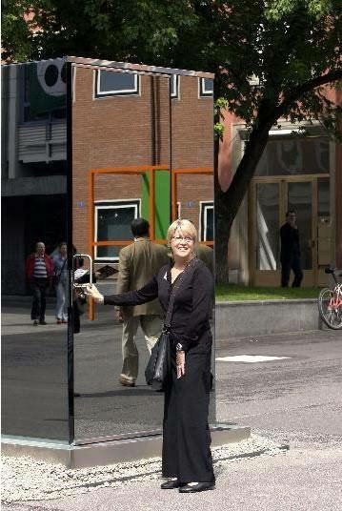  
  
Now that you've seen the ***outside*** view,   
take a look at the ***inside*** view...  
  
  
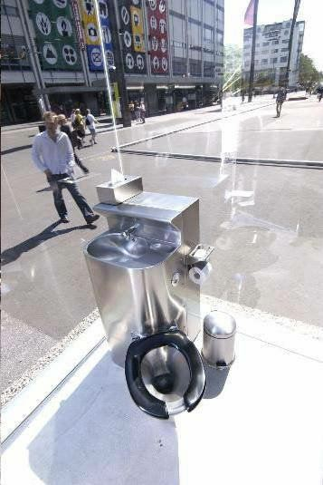  
  
It's made entirely of one-way glass!   
  
No one can see you from the *outside*,  
but when you are *inside* it's like sitting in a clear glass box!   
  
Now would you... **COULDYOU....???**

***BATHROOM   
PAINTED FLOOR!!!***  
 ***IMAGINE YOU ARE AT A PARTY .***  
 ***Tenth floor of a hi-rise building.....   
  
AND THEN YOU HAVE TO VISIT THE BATHROOM....   
  
You open the door...***

***NOW, REMEMBER THE FLOOR IS JUST A PAINTED FLOOR !***

***KINDA TAKES YOUR BREATH AWAY.....   
DOESN'T IT?   
  
Scroll sloooooooowly.   
......***

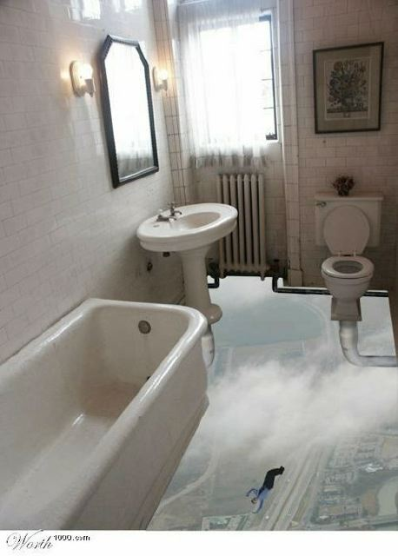

***Would this mess up your mind??? Would you   
be able to walk in To this bathroom???***  
 **THIS IS A CEILING MURAL IN A SMOKER'S LOUNGE.**

