**Some really useful ideas in here - especially the first one since I always hit a finger!!**  
**Now, why didn't I think of that?**

[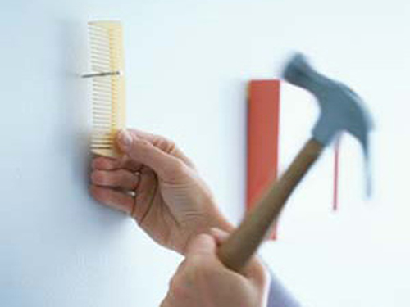](http://thechive.com/2012/02/27/a-few-simple-solutions-to-everyday-problems-16-photos/lead-358/)

[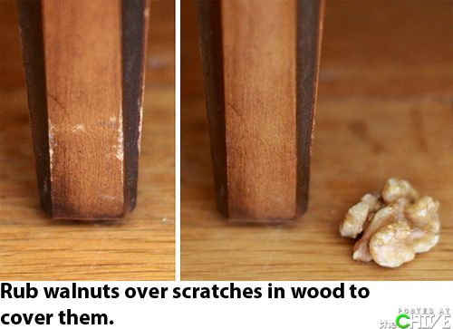](http://thechive.com/2012/02/27/a-few-simple-solutions-to-everyday-problems-16-photos/quick-fix-0/)

[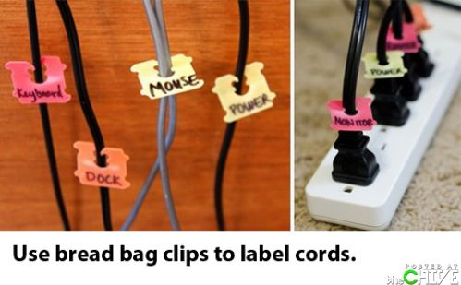](http://thechive.com/2012/02/27/a-few-simple-solutions-to-everyday-problems-16-photos/quick-fix-12/)

[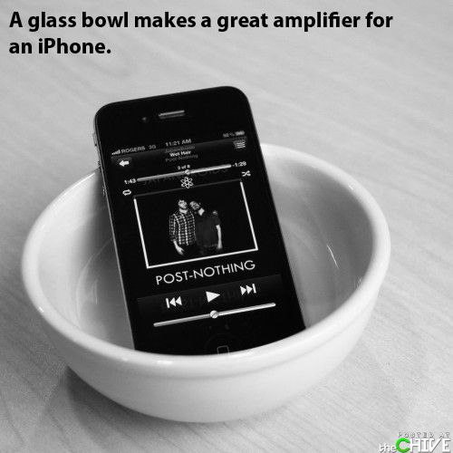](http://thechive.com/2012/02/27/a-few-simple-solutions-to-everyday-problems-16-photos/quick-fix-11/)

[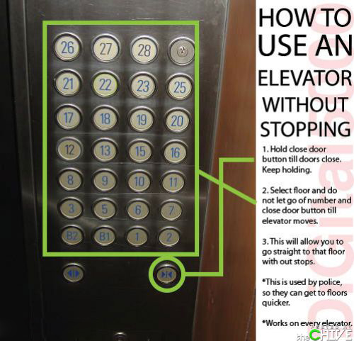](http://thechive.com/2012/02/27/a-few-simple-solutions-to-everyday-problems-16-photos/quick-fix-10/)

[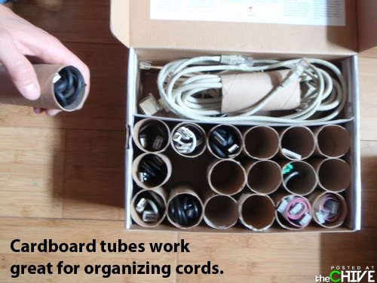](http://thechive.com/2012/02/27/a-few-simple-solutions-to-everyday-problems-16-photos/quick-fix-8/)

[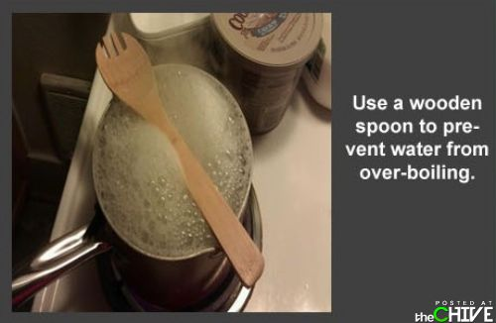](http://thechive.com/2012/02/27/a-few-simple-solutions-to-everyday-problems-16-photos/quick-fix-6/)

[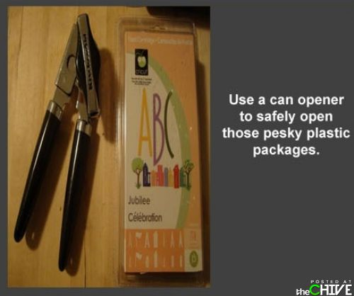](http://thechive.com/2012/02/27/a-few-simple-solutions-to-everyday-problems-16-photos/quick-fix-4/)

[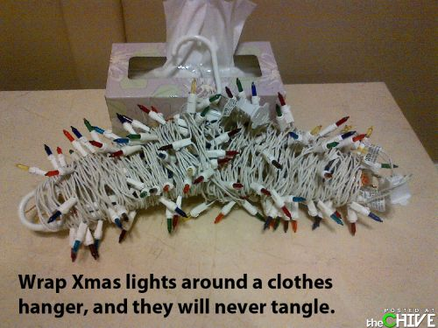](http://thechive.com/2012/02/27/a-few-simple-solutions-to-everyday-problems-16-photos/quick-fix-13/)

[](http://thechive.com/2012/02/27/a-few-simple-solutions-to-everyday-problems-16-photos/quick-fix-3/)

[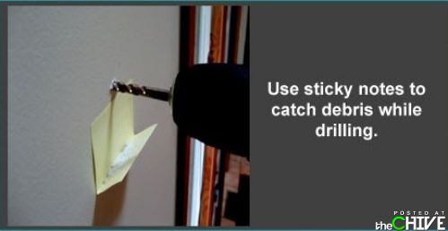](http://thechive.com/2012/02/27/a-few-simple-solutions-to-everyday-problems-16-photos/quick-fix-2/)

[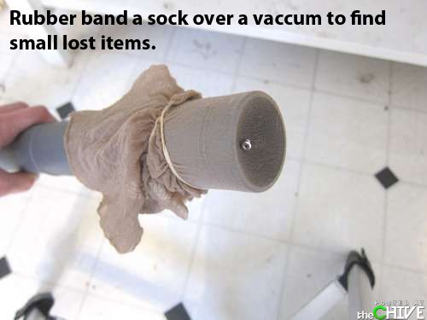](http://thechive.com/2012/02/27/a-few-simple-solutions-to-everyday-problems-16-photos/quick-fix-1/)

[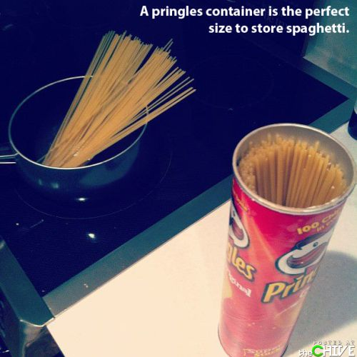](http://thechive.com/2012/02/27/a-few-simple-solutions-to-everyday-problems-16-photos/quick-fix-7/)