**Rare photos**     **(Some GOOD memories........some NOT-SO-GOOD memories!!!)   :)**

       
  **The  FIRST McDonald**           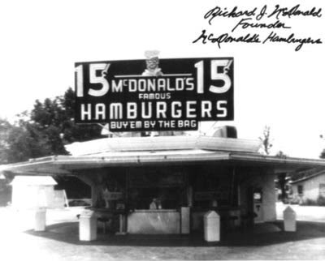     
      
      
  **CHE GUEVARA AND FIDEL CASTRO**            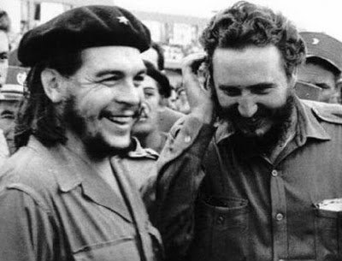     
      
      
  
**Sadam  Hussein with the noose around the neck**            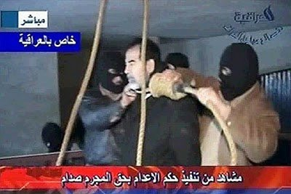     
      
    **Early  construction of Brasilia , capital of  Brazil**        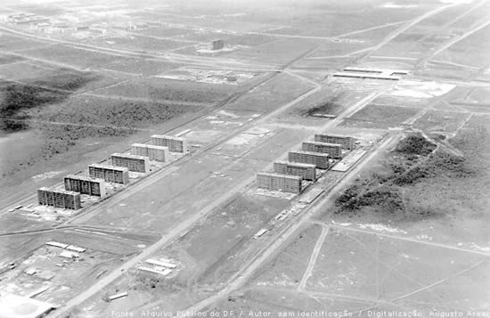     
      
  
**Papa  Pio XII and Hitler**    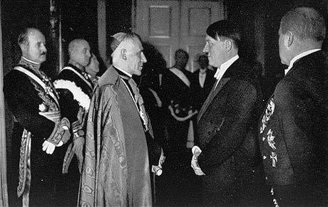     
  
**Elvis  Presley drafted into the Army**    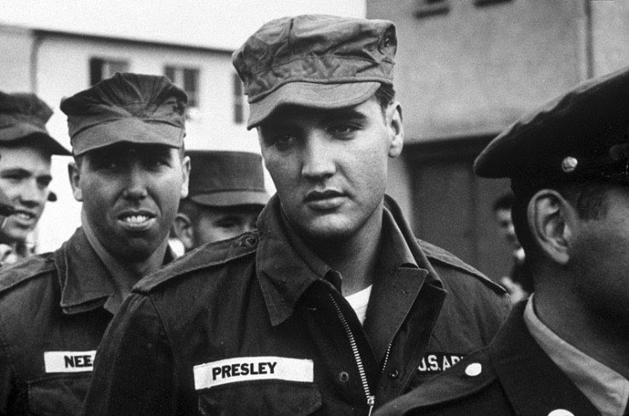     
  
**The  Beatles before they became famous**    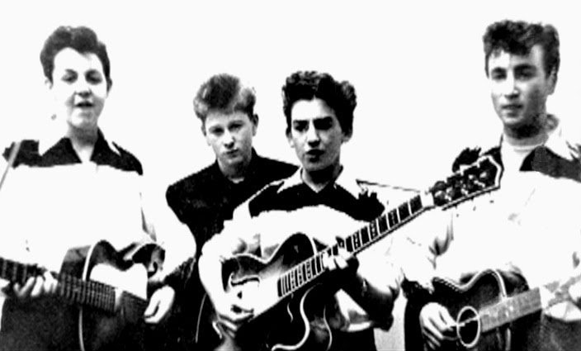     
  
**Osama  Bim Laden Family.  Osama is the one with red circle around his face**    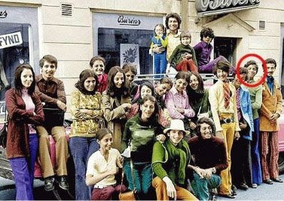     
  
**The  Titanic at the bottom of the sea**    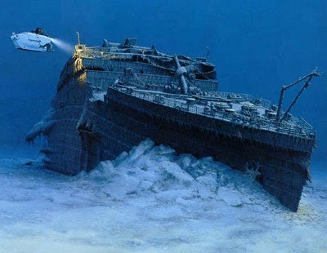     
       
Construction of Disney world  
    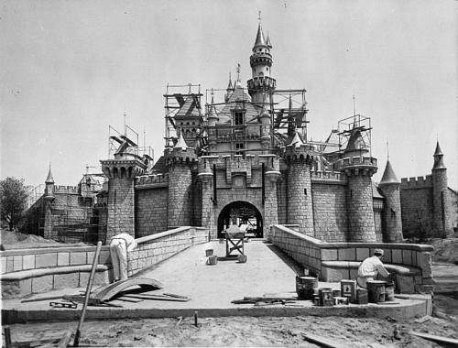     
  
**Berlin  wall being torn down**    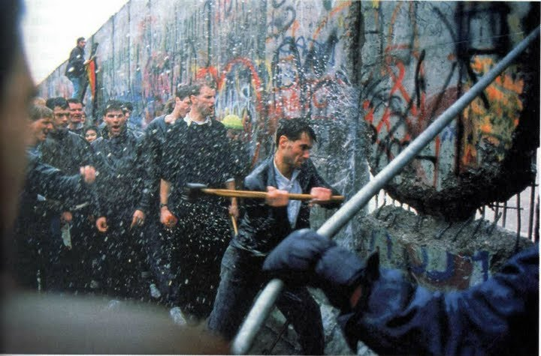     
  
**Evolution  of the Coca Cola**    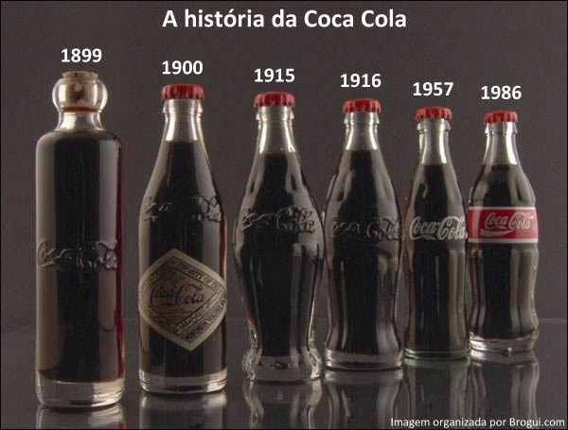     
  
**John  Lennon , signing autograph before his death.**    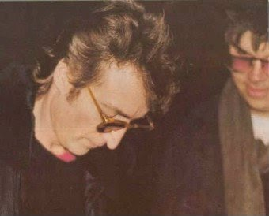     
    
  
**Chuck  Norris and Bruce Lee**    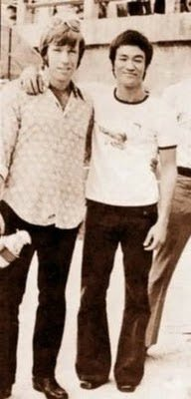     
  
**Black  physicians treating in the ER a member of the Ku Kux Klan**    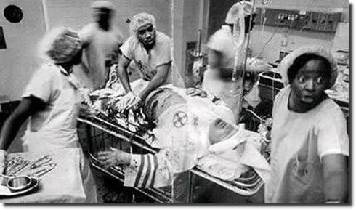     
  
**Copacabana  beach in Rio de Janeiro**    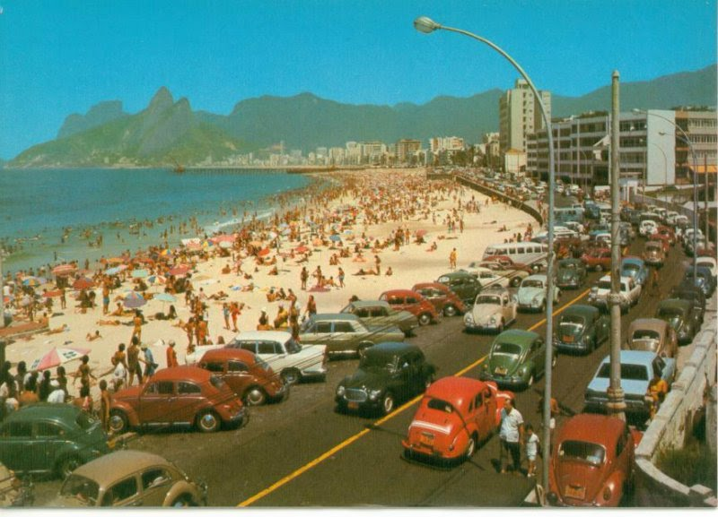     
  
**Construction  of Christ The Redeemer in Rio de Janeiro**    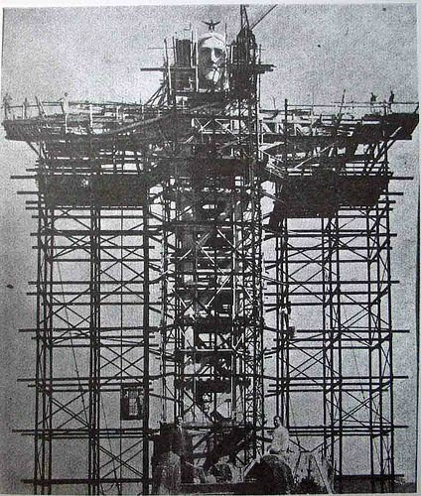     
  
**Albert  Einstein in Brazil**    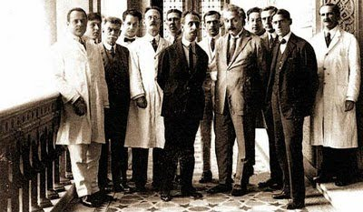     
  
**Charlie  Chaplin and Mahatma Gandhi**    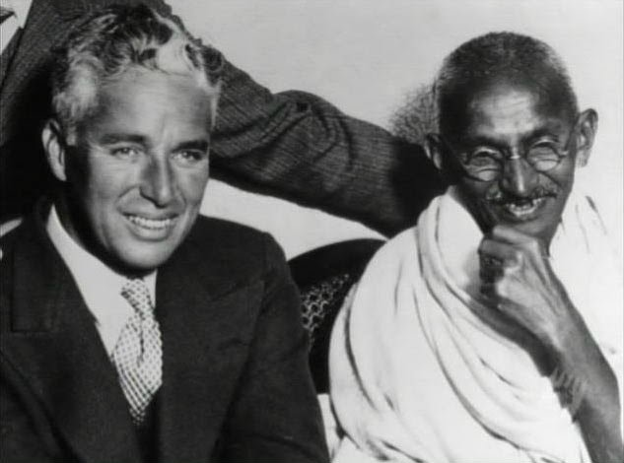     
  
**First  computer ever made**    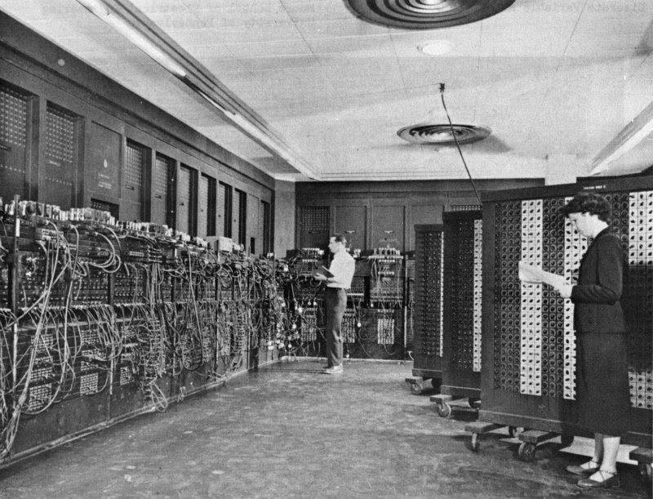     
  
**Body  of President Kennedy in 1963**    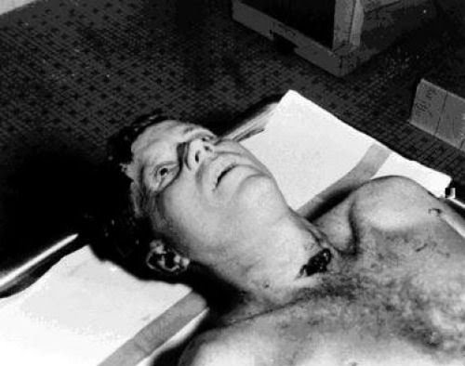     
     
  
**Construction  of the Empire State Building . This is a copy of the original photo**    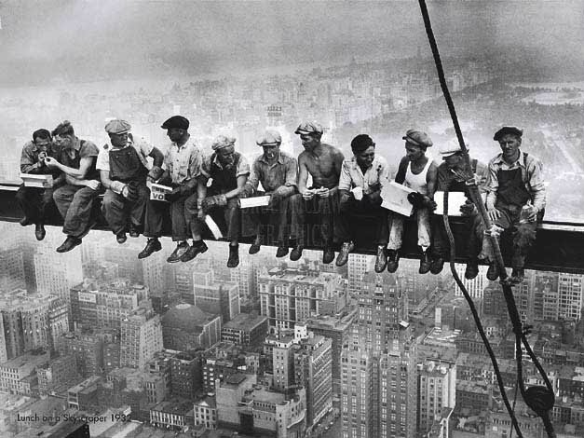   

**Martin  Luther King's cadaver**    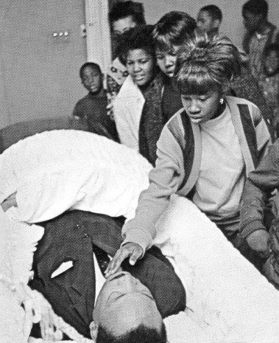   

**School  grades of Albert Einstein**     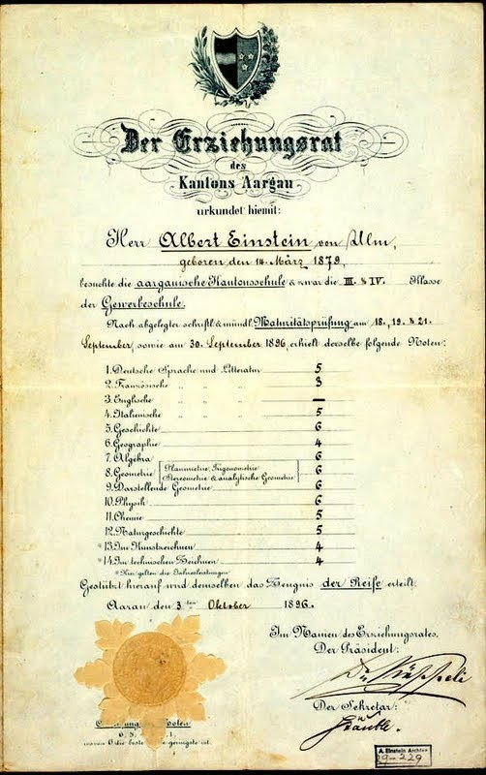     
  **????**,  
    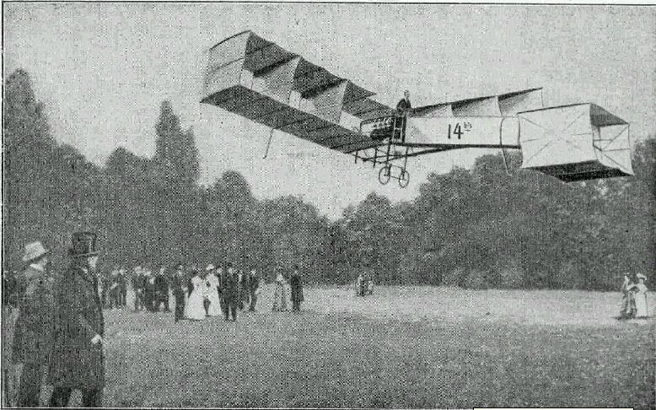   

**The  Beatles when they were adolescents**    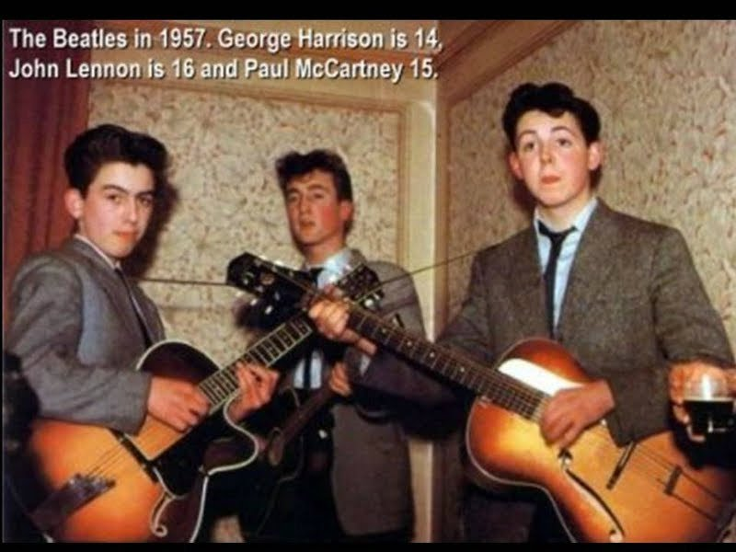   

**Google  in 1999, when they started.**    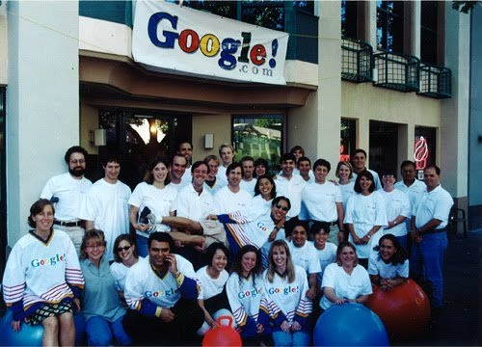   

**The  Titanic ship before sailing.**

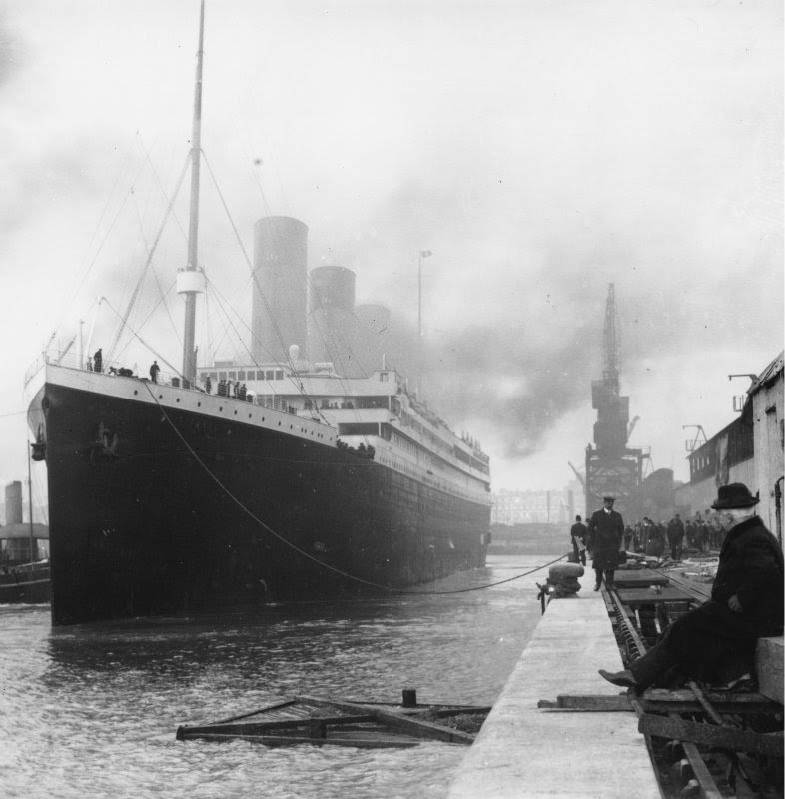

**John  Lennon's cadaver**

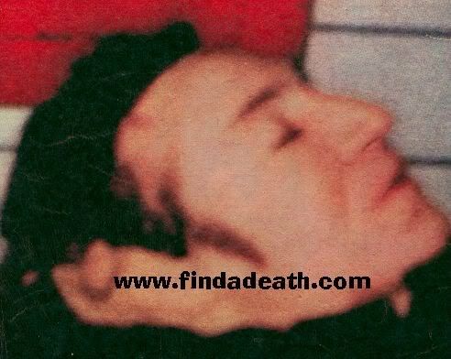

**Lady  Diana accident scene**

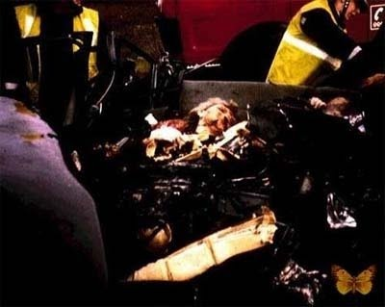

**Football  player dies while playing**

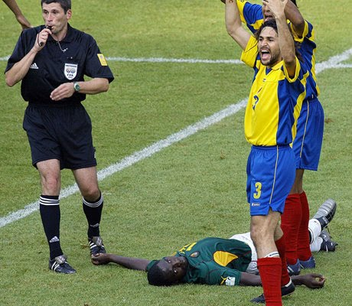     
    
   **Pope  John Paul with the man that tried to kill him.**    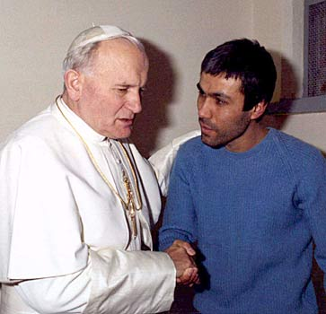     
    
   
**The  moment when George Bush was notified of the attack on the Twin Towers**    