The first photo was taken when the Chinese president went to US.
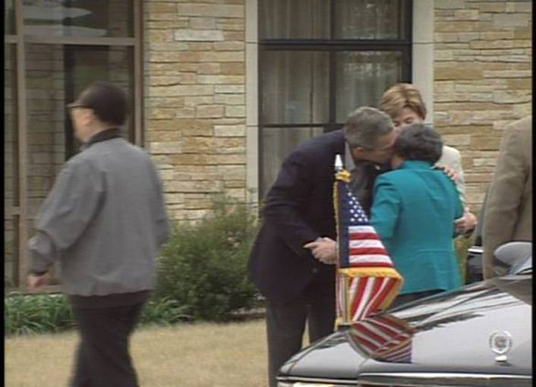

The second photo was taken when Bush went to China.
