My favorite bears.  
  
  
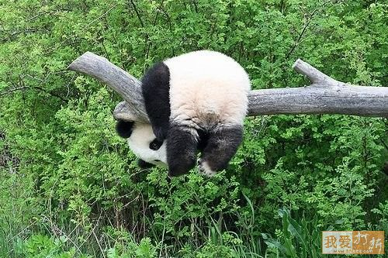  
**Mum? Can you come and get me down now?**   
  
  
  
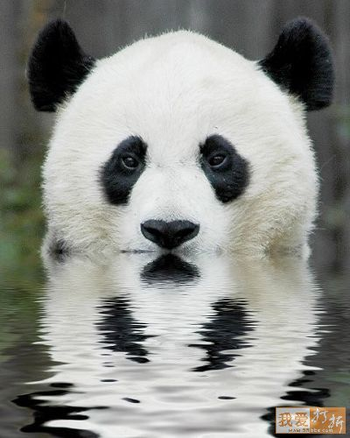  
**I'm not coming out.   
You'll have to come in and get me.**   
  
  
  
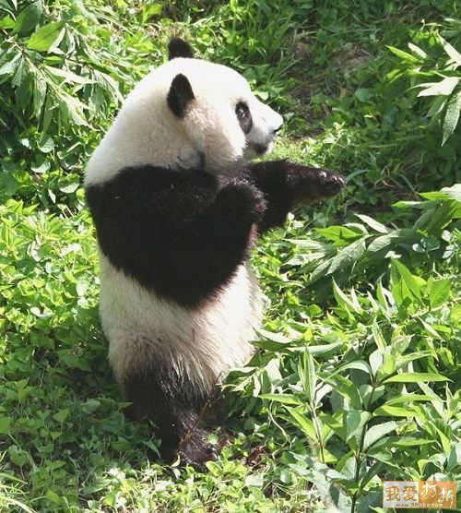  
**Kung Fu Panda...bring it on!**   
  
   
  
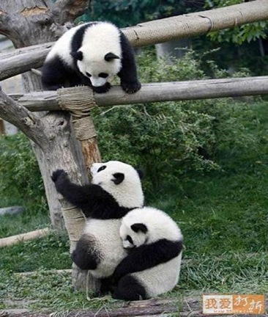  
**On the count of three.... lift!**   
  
  
  
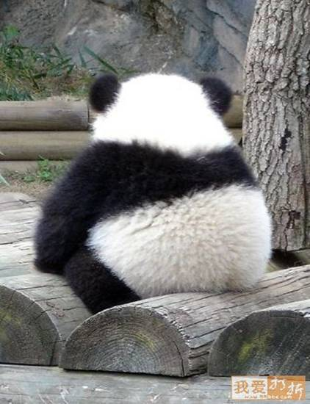  
**Does this log make my butt look fat?**   
  
  
  
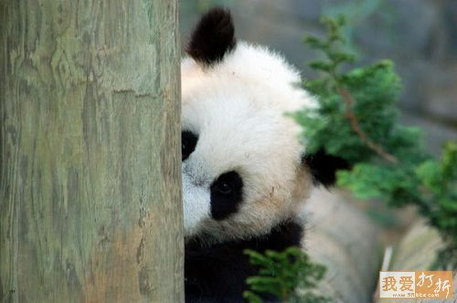  
**Betcha can't see me.....**   
    
  
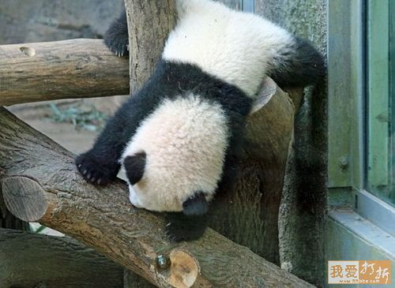  
**Oops! Slight miscalculation.**   
   
  
  
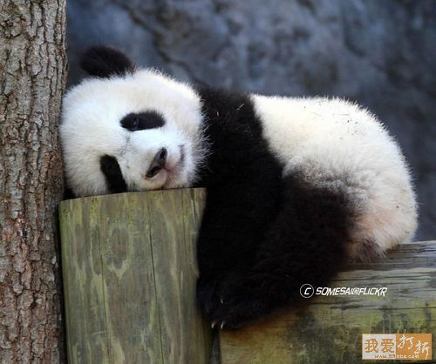  
**You go. I'll just stay here and rest my head a little bit.**   
   
  
  
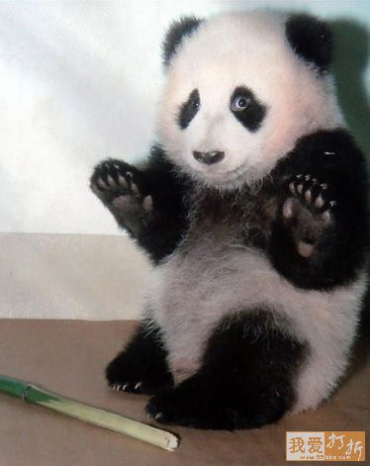  
**It wasn't me! I didn't steal this bamboo shoot!   
It was just sitting here, I swear it!**     
  
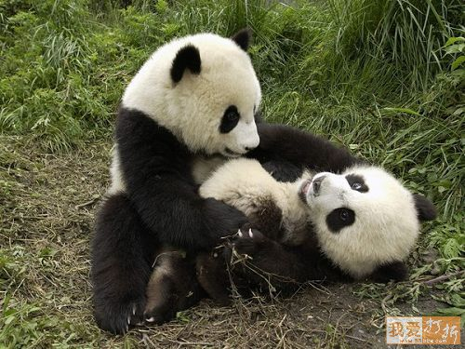  
**I'll give you 2 seconds to get off me or I'm calling Mom.**   
    
  
  
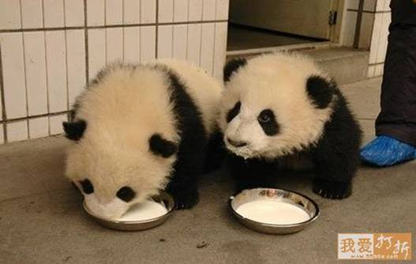  
**Pardon me but do you have a napkin?**  
   
  
  
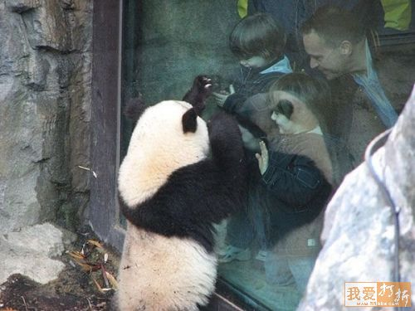  
**Darn paparazzi! Could we have a little privacy please?**   
    
  
  
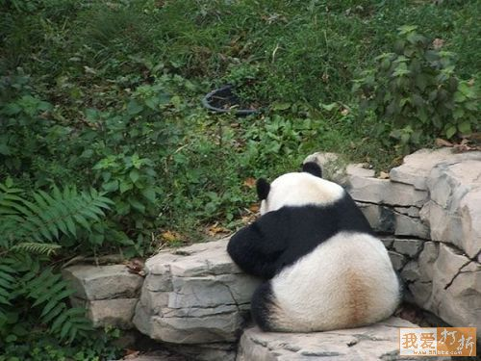  
**Dear Martha Stewart:   
I have this brown stain on my nice, white, fluffy butt...**   
   
    
  
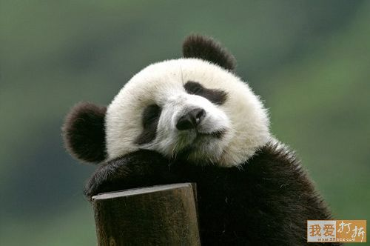  
**Shhhh! I'm reviewing...**   
  
  
  
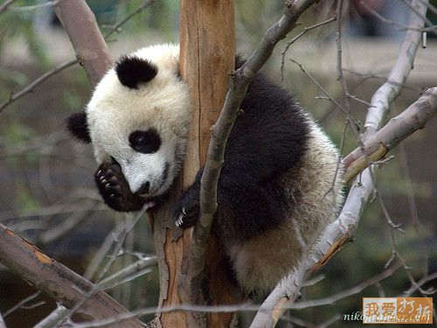  
**I cannot believe that I'm stuck in this tree again.   
What is the matter with me?**   
   
  
  
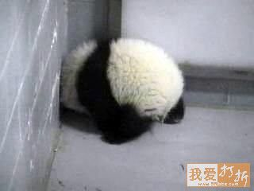  
**I'm sure there's a way out somewhere.   
I saw an ant go this way yesterday.**      
  
  
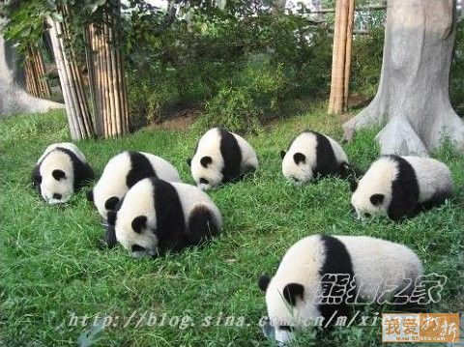  
**Pandas looking for lost earrings....**   
  
   
  
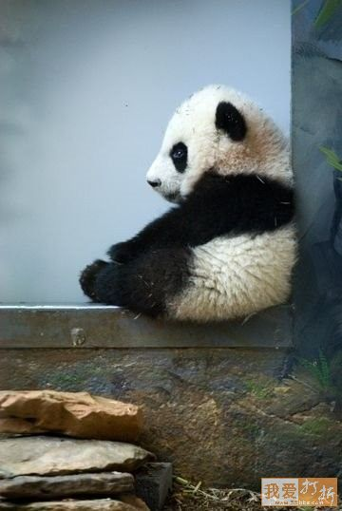  
**Absolutely nothing accomplished.   
The perfect day for a panda...**   
  
  
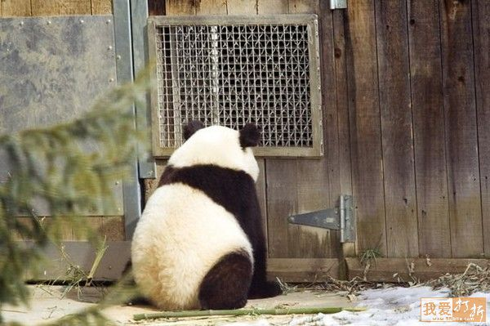  
**Forgive me Father, for I have sinned...** 