**How do you like Chinese Huahin?!  Can you believe this!!!!!!!!!!!!!!!!!!!!!!!!!!!!!!!!!!!!!!!**

**Love This!  
When you need to relax and just get away from it all.....**     
**May I suggest.....'A Day at the beach in *CHINA* '**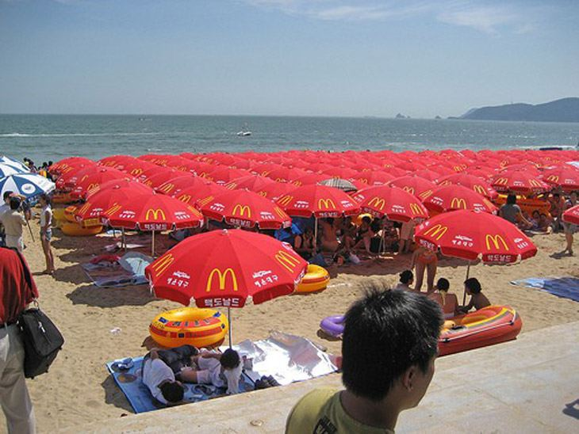  
  
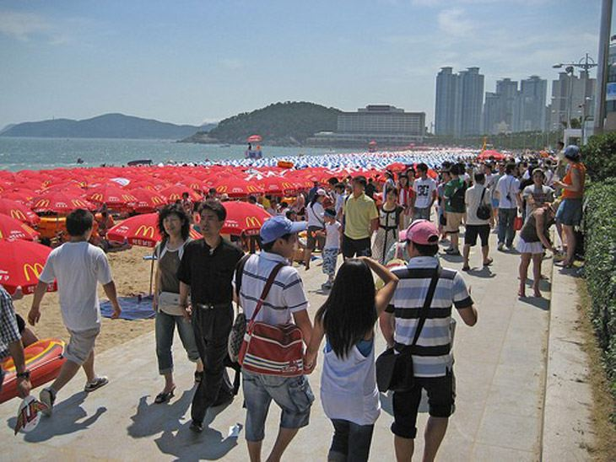  
  
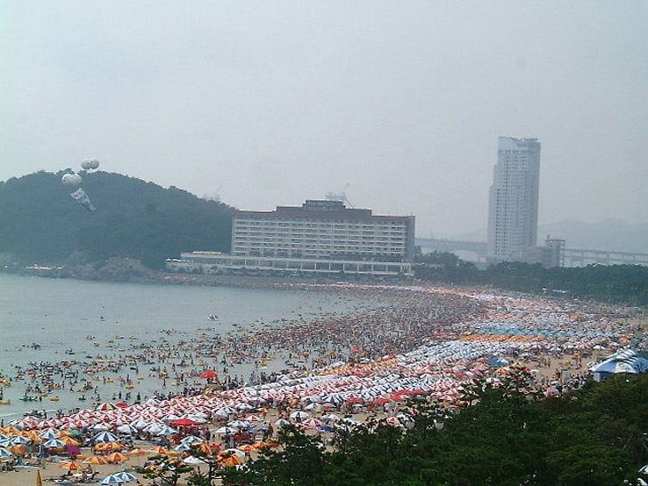  
  
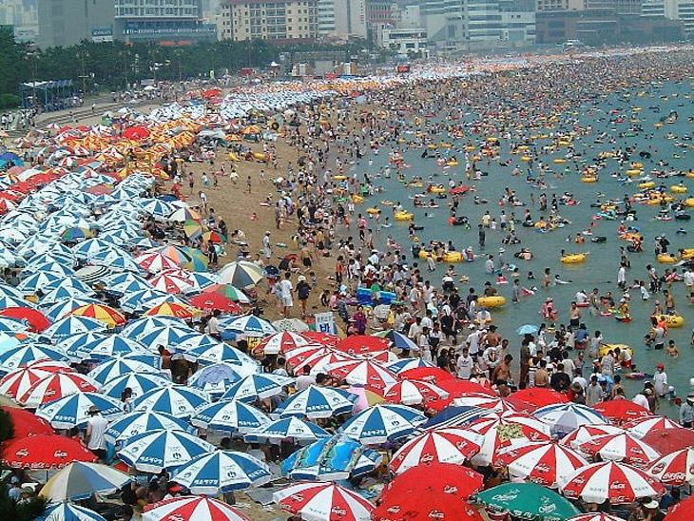  
  
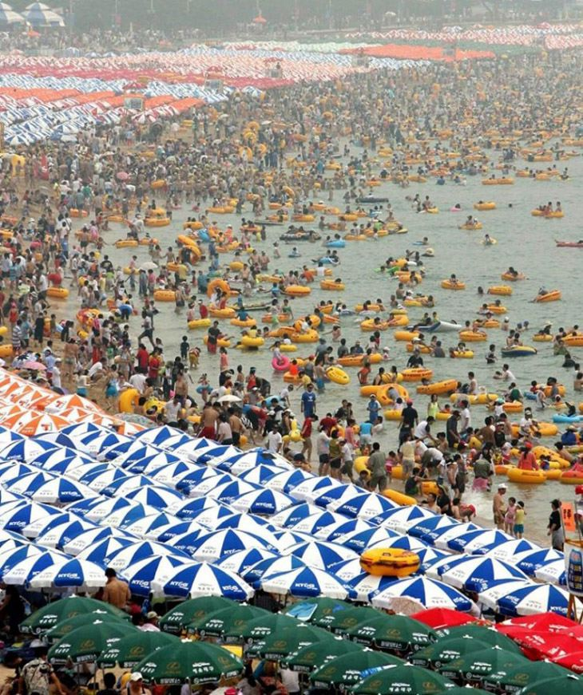  
  
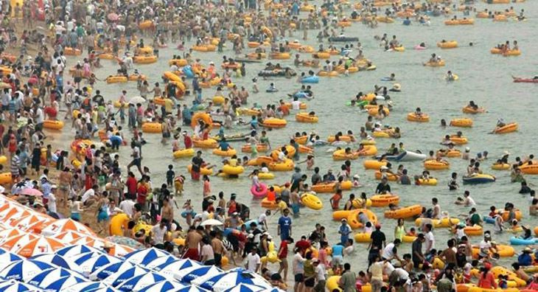  
  
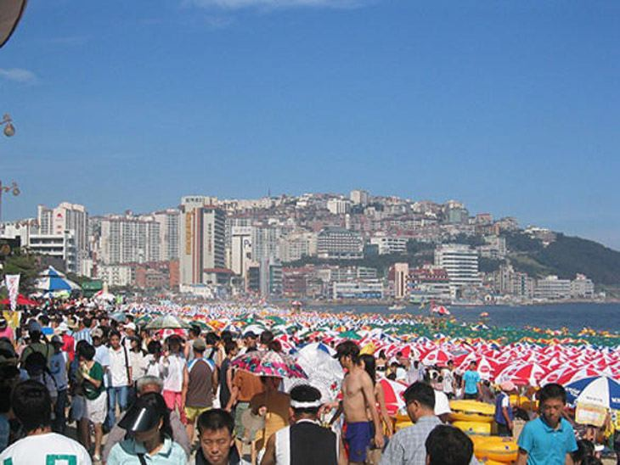     
  
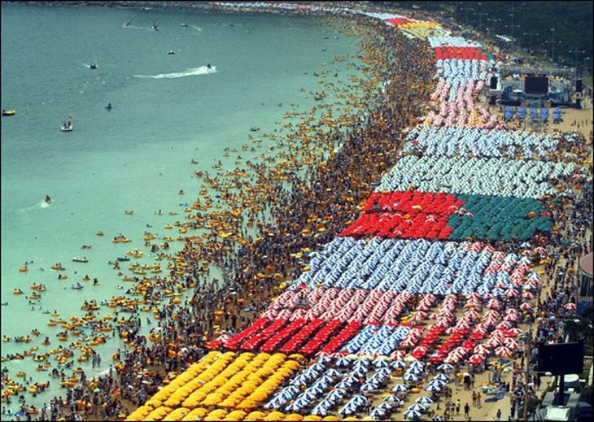  
 ***I WONDER WHERE THE BATHROOMS ARE????******Where do they park their cars???     
Do they have lifeguards??***