**Geography Of A Woman**



**Between 18 and 22, a woman is like Africa. Half discovered, half wild, fertile and naturally Beautiful!**  
  


**Between 23 and 30, a woman is like Europe. Well developed and open to trade, especially for someone of real value.**

**  
Between 31 and 35, a woman is like Spain, very hot, relaxed and convinced of her own beauty.**  
  
**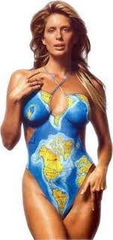  
Between 36 and 40, a woman is like Greece, gently aging but still a warm and desirable place to visit.**  
  
**  
Between 41 and 50, a woman is like Great Britain, with a glorious and all conquering past.**  
  
**  
Between 51 and 60, a woman is like Israel,has been through war, doesn't make the same mistakes twice, takes care of business.**

**  
Between 61 and 70, a woman is like Canada, self-preserving, but open to meeting new people.  
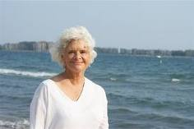  
After 70, she becomes Tibet. Wildly beautiful, with a mysterious past and the wisdom of the ages. An adventurous spirit and a thirst for spiritual knowledge.  
  
THE GEOGRAPHY OF A MAN**

**Between 1 and 80, a man is like Iran,**

**ruled by nuts.**

**THE END.**