Clever and Cute Logos

I was not aware of these things...guess I'll have to start watching logos more carefully.

If you look at the center of this logo, you can see two people enjoying a Tostito chip with a bowl of salsa. This logo conveys an idea of people connecting with each other.
Formula 1
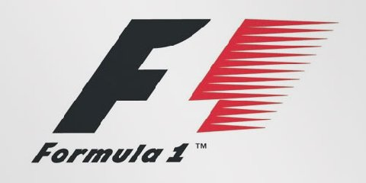
At first, this logo might not make much sense. But if you look closely, you'll see the number 1 in the negative space between the F and the red stripes. I also love how this logo communicates a feeling of speed.
Milwaukee Brewers
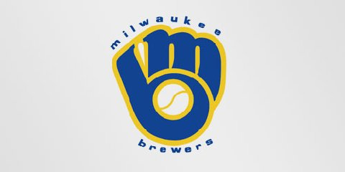
The Milwaukee Brewers is a professional baseball team from Milwaukee, Wisconsin (well, duh!). Their logo is actually made up of the letters M (on top) and B (below the m). These two letters also form a baseball glove.
Northwest Airlines

This simple looking logo actually carries a lot of information. First of all you can see the letters N and W, the first two letters of the brand name. But what most people don't see is the compass that points to the Northwest, another reference to the brand name.

This logo doesn't seem to hide much at first sight, but it gives you a little insight in the philosophy behind the brand. First of all, the yellow swoosh looks like a smile: Amazon wants to have the best customer satisfaction. The swoosh also connects the letters a and z, meaning that this store has everything from a to z.
Toblerone
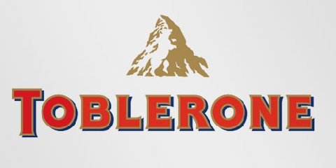
Toblerone is a chocolate-company from Bern, Switzerland. Bern is sometimes called 'The City Of Bears'. They have incorporated this idea in the Toblerone logo, because if you look closely, you'll see the silhouette of a bear.
Baskin Robins
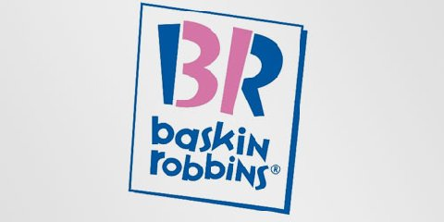
The old logo of Baskin Robbins had the number 31 with an arc above it. The new logo took this idea to the next level. The pink parts of the BR still form the number 31, a reference to the 31 flavors.
Sony Vaio
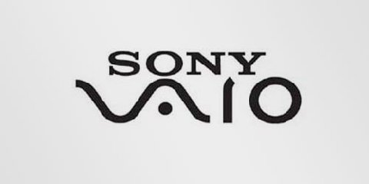
Sony Vaio is a well known brand of laptops. But did you know that the name Vaio logo also had a hidden meaning? Well, the first two letters represent the basic analogue signal. The last two letters look like a 1 and 0, representing the digital signal.

Do you see any arrows on FedEx's logo? I saw it a few times at another site saying that there's an arrow hidden in the FedEx logo, but I couldn't find it. I now know where it is, it's your turn to find it.
Ok, give up? (scroll down)
(The clue is that the arrow is located in between the alphabet E and X, and the arrow is white, acting as a background.)

