**America's Problem -**

**The current financial crisis explained in a single picture:**

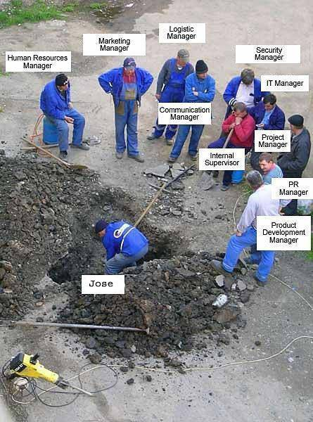r

This financial crisis is forcing State and local agencies to make some tough decisions.

If things continue for much longer, there's a real risk that we may have to lay off Jose.