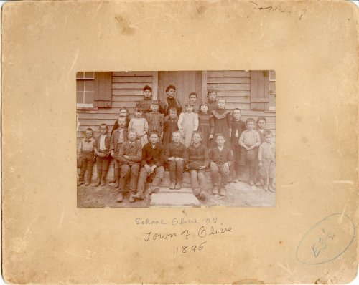  
   
What it took to get an 8th grade education in 1895  
  
    Remember when grandparents and great-grandparents stated that they only had an 8th grade education? Well, check this out. Could any of us have passed the 8th grade in 1895?   
  
    This is the eighth-grade final exam from 1895 in Salina, Kansas, USA. It was taken from the original document on file at the Smokey Valley Genealogical Society and Library in Salina, and reprinted by the Salina Journal.

**8th Grade Final Exam:  Salina ,  KS - 1895**

**Grammar (Time, one hour)**1. Give nine rules for the use of capital letters.  
2. Name the parts of speech and define those that have no modifications..   
3. Define verse, stanza and paragraph  
4. What are the principal parts of a verb? Give principal parts of 'lie,''play,' and 'run.'   
5. Define case; illustrate each case.  
6 What is punctuation? Give rules for principal marks of punctuation.   
7 - 10. Write a composition of about 150 words and show therein that you understand the practical use of the rules of grammar.

**Arithmetic (Time,1 hou r 15 minutes)**1. Name and define the Fundamental Rules of Arithmetic.  
2. A wagon box is 2 ft. Deep, 10 feet long, and 3 ft.. Wide. How many bushels of wheat will it hold?   
3. If a load of wheat weighs 3,942 lbs., what is it worth at 50cts/bushel, deducting 1,050 lbs. For tare?   
4. District No 33 has a valuation of $35,000. What is the necessary levy to carry on a school seven months at $50 per month, and have $104 for incidentals?   
5. Find the cost of 6,720 lbs. Coal at $6.00 per ton.  
6. Find the interest of $512.60 for 8 months and 18 days at 7 percent.   
7. What is the cost of 40 boards 12 inches wide and 16 ft.. Long at $20 per metre?  
8. Find bank discount on $300 for 90 days (no grace) at 10 percent.  
9. What is the cost of a square farm at $15 per acre, the distance of which is 640 rods?   
10. Write a Bank Check, a Promissory Note, and a Receipt.

**U.S. History (Time, 45 minutes)**1. Give the epochs into which U.S. History is divided  
2. Give an account of the discovery of  America by  Columbus    
3. Relate the causes and results of the Revolutionary War.  
4. Show the territorial growth of the  United States    
5. Tell what you can of the history of  Kansas    
6. Describe three of the most prominent battles of the Rebellion.   
7. Who were the following: Morse, Whitney,  Fulton ,  Bell ,  Lincoln , Penn, and Howe?  
8. Name events connected with the following dates: 1607, 1620, 1800, 1849, 1865.

**Orthography (Time, one hour) [Do we even know what this is?]**1. What is meant by the following: alphabet, phonetic, orthography, etymology, syllabication  
2. What are elementary sounds? How classified?  
3. What are the following, and give examples of each: trigraph, subvocals, diphthong, cognate letters, linguals& nbsp;  
4. Give four substitutes for caret 'u.'  
5. Give two rules for spelling words with final 'e.' Name two exceptions under each rule.  
6. Give two uses of silent letters in spelling. Illustrate each.   
7. Define the following prefixes and use in connection with a word: bi, dis-mis, pre, semi, post, non, inter, mono, sup.  
8. Mark diacritically and divide into syllables the following, and name the sign that indicates the sound: card, ball, mercy, sir, odd, cell, rise, blood, fare, last.   
9. Use the following correctly in sentences: cite, site, sight, fane, f ain, feign, vane , vain, vein, raze, raise, rays.  
10. Write 10 words frequently mispronounced and indicate pronunciation by use of diacritical marks and by syllabication.

**Geography (Time, one hour)**1 What is climate? Upon what does climate depend?  
2. How do you account for the extremes of climate in  Kansas ?   
3. Of what use are rivers? Of what use is the ocean?  
4. Describe the mountains of  North America    
5. Name and describe the following:  Monrovia ,  Odessa ,  Denver ,  Manitoba ,  Hecla ,  Yukon , St. Helena, Juan Fernandez, Aspinwall and  Orinoco     
6. Name and locate the principal trade centers of the U.S. Name all the republics of  Europe and give the capital of each.  
7. Why is the  Atlantic  Coast colder than the Pacific in the same latitude?   
8. Describe the process by which the water of the ocean returns to the sources of rivers.  
9. Describe the movements of the earth. Give the inclination of the earth.

**Notice that the exam took FIVE HOURS to complete.  
  
Gives the saying 'he only had an 8th grade education' a whole new meaning, doesn't it?!   Also shows you how poor our education system has become.**