25 clever ideas to make life easier

.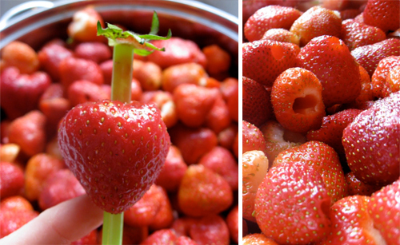

Why didn’t I think of that?! We guarantee you’ll be uttering those words more than once at these ingenious little tips, tricks and ideas that solve everyday problems … some you never knew you had! (Above: hull strawberries easily using a straw).

###### Clever ideas: use a walnut to heal furniture scratches

###### Rubbing a walnut over scratches in your furniture will disguise dings and scrapes.

###### Clever ideas: WD40 for cleaning crayon off TV screens

###### Remove crayon masterpieces from your TV or computer screen with WD40 (also works on walls)..

###### Clever ideas: keep a cut apple from going brown

###### Stop cut apples browning in your child’s lunch box by securing with a rubber band.

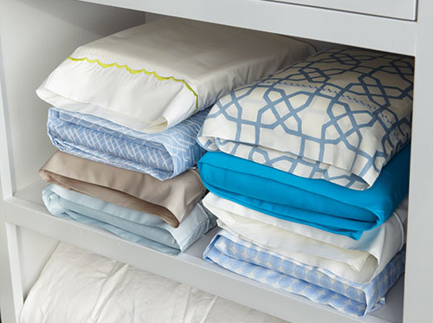

###### Overhaul your linen cupboard – store bed linen sets inside one of their own pillowcases and there will be no more hunting through piles for a match.

###### Clever ideas: bowl as iPhone sound amplifier

###### Pump up the volume by placing your iPhone / iPod in a bowl – the concave shape amplifies the music.

###### Cleaver ideas: wet wipe dispenser as plastic bag storage

###### Re-use a wet-wipes container to store plastic bags.

###### Clever ideas: baby powder to remove sand from feet

###### Add this item to your beach bag. Baby powder gets sand off your skin easily – who knew?!

###### Clever ideas: gift wrap storage on cupboard ceiling

###### Look up! Use wire to make a space to store gift wrap rolls against the ceiling, rather than cluttering up the floor.

###### Clever idea: stocking over vacuum to pick up lost items

###### Gotcha! Find tiny lost items like earrings by putting a stocking over the vacuum hose.

###### Clever idea: box lid cupcake holder

###### Make an instant cupcake carrier by cutting crosses into a box lid..

###### Clever idea: how to fold a fitted sheet

###### For those who can’t stand the scrunching and bunching: how to perfectly fold a fitted sheet.

###### Clever idea: magnetic bobbypin storage

###### Forever losing your bathroom essentials? Use magnetic strips to store bobby pins (and tweezers and clippers) behind a vanity door

###### Clever idea: use shower caps to hold shoes when packing

###### A tip for holiday packing. Store shoes inside shower caps to stop dirty soles rubbing on your clothes. And you can find them in just about every hotel!.

###### Clever idea: muffin pan craft storage

###### A muffin pan becomes a craft caddy. Magnets hold the plastic cups down to make them tip-resistant.

###### Clever idea: bread tags as cable labels

###### Bread tags make the perfect-sized cord labels.

###### Clever idea: cook cupcakes in ice cream cones

Bake cupcakes directly in ice-cream cones – so much more fun and easier for kids to eat. Definitely doing this!

###### Clever idea: microwave your own popcorn in a plain paper bag

###### Microwave your own popcorn in a plain brown paper bag. Much healthier and cheaper than the packet stuff.

###### Clever idea: use a tension rod to hang spray bottles

###### Brilliant space-saver: install a tension rod to hang your spray bottles. Genius!

###### Clever idea: how to make heart-shaped eggs

###### Win friends at breakfast with this heart-shaped egg tutorial. Aww shucks!.

###### Clever idea: use upside-down muffic pan to make cookie bowls

Turn your muffin pan upside down, bake cookie-dough over the top and voila – you have cookie bowls for fruit or ice-cream. .

###### Clever idea: freeze aloe vera lotion for soothing burns

###### Freeze Aloe Vera in ice-cube trays for soothing sunburn relief.

###### Clever idea: gutter veggie garden

###### Gutter garden: Create a window-box veggie patch using guttering.

.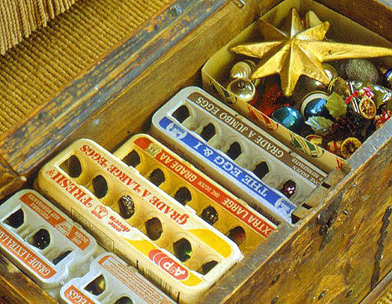

###### Use egg cartons to separate and store your Christmas decorations.

###### Clever ideas: velcro strip on wall to hold soft toys

Attach a Velcro strip to the wall to store soft toys.